Introduction:
Bayesian optimization is a method that contains active and adaptive learning for goal-oriented outcomes. Benefits of this framework include its efficiency when evaluations are costly, ability to accelerate innovation, and ease of use in JMP Pro.
All material for this case study can be accessed in the JMP Journal file Bayesian Optimization Journal.

Case Study 1: Maximizing Concrete Compressive Strength

Background:
Concrete is formed by combining water, cement, and crushed rock. The water-to-cement balance is crucial for compressive strength, the amount of force the concrete can withstand before failing. An excess of water increases porosity and shrinkage, weakening the concrete, while insufficient water causes cracking and deformation. Therefore, finding the optimal water to be used in the mixture is essential to maximize the compressive strength of the concrete.

In this application, we will investigate a case where Bayesian optimization can provide meaningful analysis when evaluations are costly. Suppose a materials engineering firm must determine the amount of water to be used in a concrete mixture for a new high-rise apartment. Engineers want to find the amount of water (kg/m³) that maximizes the compressive strength of concrete (MPa).

Goals:
- Explore the Bayesian Optimization platform in JMP Pro.
- Optimize a response using one factor.
- Demonstrate active and adaptive learning.

How much water (mass per unit volume) should be used to maximize the compressive strength of the concrete?
- Click the gray triangle next to Case Study 1 and click Concrete Data.
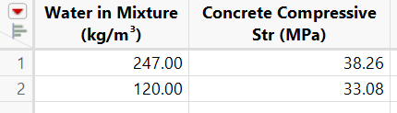

Data for two measurements of concrete compressive strength with differing water amounts
Factor Variable:
- Water in Mixture (kg/m³): Mass of water per one cubic meter of cement mixture
Response Variable:
- Concrete Compressive Str (MPa): Observed compressive strength of the concrete

Set up Bayesian Optimization in JMP:
Let’s use the Bayesian optimization feature in JMP Pro with the two observations given.
- Select Analyze > Specialized Modeling > Bayesian Optimization.
- Select Concrete Compressive Str (MPa), then click Y.
- Select Water in Mixture (kg/m³), then click X.
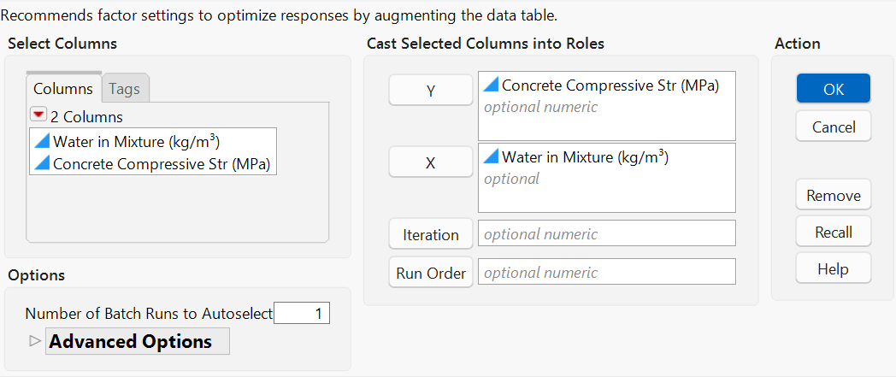

Under the Options header, the Number of Batch Runs to Autoselect setting can adjust the batch size for Bayesian Optimization. For these exercises, we will use the default size of 1.
- Click OK.

The Bayesian optimization window in JMP has three tabs:
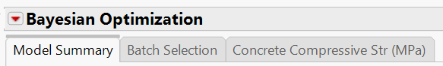

Model Summary: Includes a variety of graphs, diagnostics, and the prediction profiler
Batch Selection: Shows next iteration, reason added, and options to add to the data table
Outcome Variable: Provides diagnostics for the outcome variable as well as additional prediction profilers
Let’s see what happened:
In the Model Summary tab, we can see a prediction profiler for the concrete compressive strength variable. Points can be added to the graph:
- Click the red triangle next to All Responses Profiler > Data Points.
- Right click on the y-axis, then select Axis Settings. Change the y-axis minimum to 20 and maximum to 55.
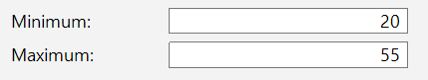

- Click Ok.
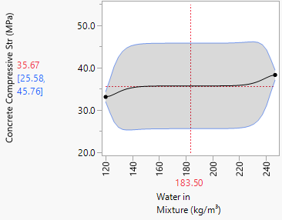
What’s displayed: What’s happening:

The visualization in the prediction profiler shows the historical data, the starting points. The graph on the right shows the “true” function overlayed in green for illustrative purposes. Notice the fitted curve does not resemble the objective function. Additionally, there is large uncertainty, shown in the gray confidence bounds. We need more data… space fill!

Complete Iteration 1:
The Bayesian Optimization platform in JMP Pro automatically creates parameters for the next trial. In the Batch Selection tab, add settings for the next iteration to the data table:
- Select Batch Selection > Make Table.
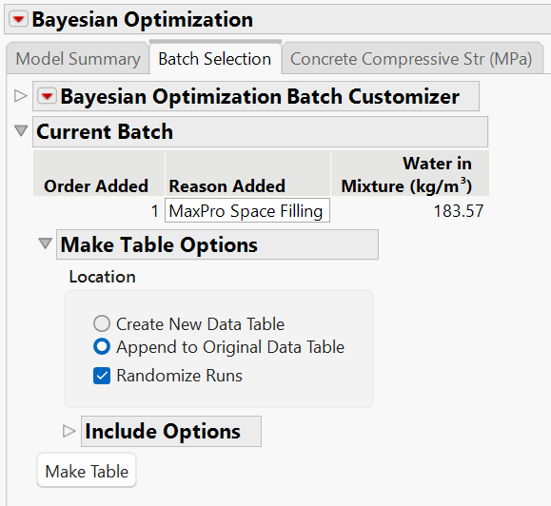

- Close the Bayesian Optimization platform.
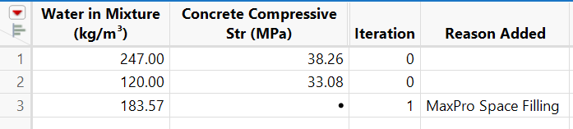
Updated Data Table:

A new row is created for the next test of concrete compressive strength.
Two new columns are automatically added to the data table:
Iteration: Keeps track of the number of iterations of Bayesian Optimization
Reason Added: Why the point was added; in this case to space fill

Testing:
In this example, the engineering firm would conduct an experiment to measure concrete compressive strength using 183.57 kg/m³ of water. This value would be recorded in the column Concrete Compressive Str (MPa) where currently there is missing value.
For simplicity, we will use a simulated value for compressive strength when 183.57 kg/m³ of water is used in the concrete.
- Type 30.95 in the column Concrete Compressive Str (MPa).
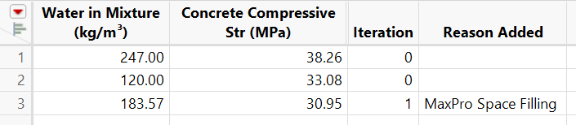

Complete next iteration:
Now that we have measured compressive strength for the trial, we can follow a similar procedure for the next iteration.
When the first iteration of Bayesian Optimization was completed, script BO Start Up Script for Batch 1 was added to the table panel. It is essential to run this script to complete the next iteration because it provides a jump start to the optimization routine.
- Click the green play button next to BO Start Up Script for Batch 1.
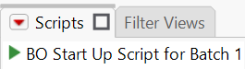

Let’s see what happened:
In the Model Summary tab, visualize the previous iteration and how the Bayesian Optimization space fills when there is high uncertainty.
- Click the red triangle next to All Responses Profiler > Data Points.
- Right click over the y-axis, then select Axis Settings. Change the y-axis minimum to 20 and maximum to 55.

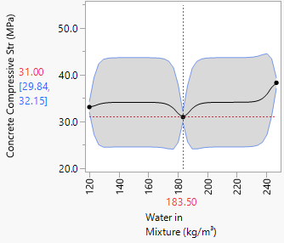
What’s displayed: What’s happening:

The prediction profiler now contains the third data point (in yellow) from the previous iteration. Notice the confidence bounds (in gray) updated as there is higher confidence in regions nearby the new sample and greater uncertainty farther away.
However, the “unknown” curve fit to the observed data doesn’t resemble the objective and there is still extensive uncertainty. We still need more data… space fill!
Add next iteration to the data table:
- Select Batch Selection > Make Table.
- Close the Bayesian Optimization platform.

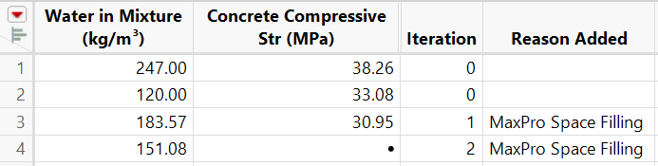

- Add the simulated value 49.30 to the column Concrete Compressive Str (MPa) where there is a missing value.
For iterations 3-6, a similar process is repeated. The measured compressive strength for each iteration will be given.

Open Bayesian Optimization Platform:
- In the table panel, click the green play button next to the most recent script produced by Bayesian Optimization.
In the Model Summary tab, visualize the previous iteration:
- Click the red triangle next to All Responses Profiler > Data Points.
- Right click over the y-axis, then select Axis Settings. Change the y-axis minimum to 20 and maximum to 55.
Add next iteration to the data table:
- Select Batch Selection > Make Table.
- Close the Bayesian Optimization platform.
Record measured compressive strength:
- Locate the measured compressive strength in the table below corresponding to the Bayesian Optimization iteration number. Add this value to the column Concrete Compressive Str (MPa) where there is a missing value.
Next iteration:
- Repeat steps 19-24 for iterations 3-6.

Measured values for Concrete Compressive Str (MPa):
Iteration Number | Measured Compressive Strength
Iteration 3 | 33.01
Iteration 4 | 51.85
Iteration 5 | 42.31
Iteration 6 | 28.58

The following table is produced following iteration 6:
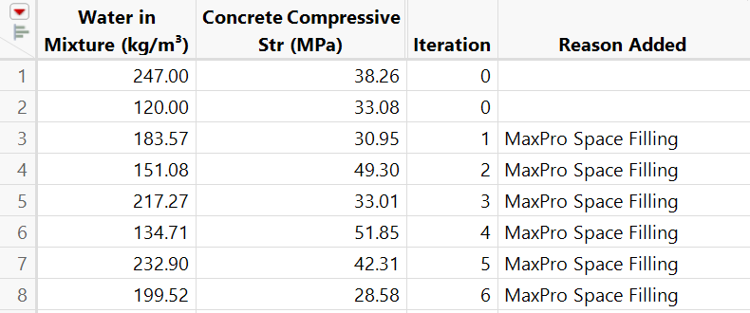

Notice after several iterations, the curve through the sampled points will begin to resemble the true function as the model “learns” from the previous results.
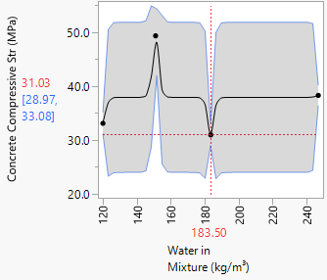
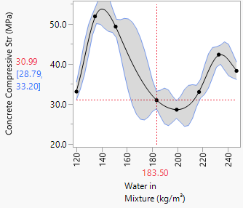
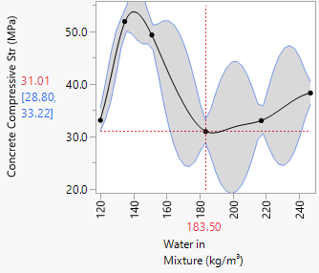
Iteration 2 Iteration 4 Iteration 6

Let’s resume with a later iteration.
- Close the data table (without saving changes).
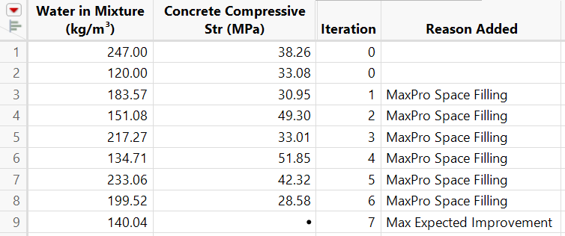
- Navigate to the JMP Journal and click Iteration 7.

By iteration 7, the column Reason Added changes to reflect the next stage: refine the model with Max Expected Improvement. Model refinement targets regions where there is opportunity to improve the current best outcome. Can we increase the concrete compressive strength beyond 51.85 MPa?
Using 140.04 kg/m³ water, the simulated value is 54.09 MPa. Yes, there is improvement!
- Add 54.09 to the column Concrete Compressive Str (MPa) where there is a missing value.

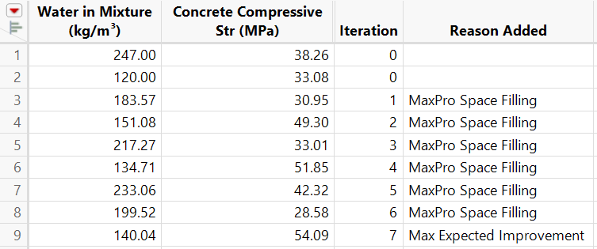
Previous Maximum
New Maximum

Let’s see how this works. To visualize the model refinement step, open the Bayesian Optimization platform:
Let’s see what happened:
- Click the green play button next to BO Start Up Script for Batch 7.
Shown in the prediction profiler, Bayesian Optimization determined it has completed exploration and now seeks to improve the maximum concrete compressive strength.

Iteration 7
- Click the red triangle next to All Responses Profiler > Data Points.
- Right click over the y-axis, then select Axis Settings. Change the y-axis minimum to 20 and maximum to 55.
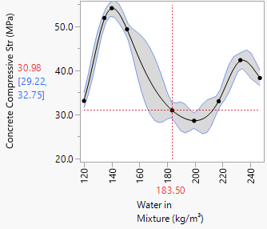

Iteration 7 begins the exploitation phase of Bayesian optimization as priority shifts to areas with high concrete compressive strength.

Add next iteration to data table:
- Select Batch Selection > Make Table.
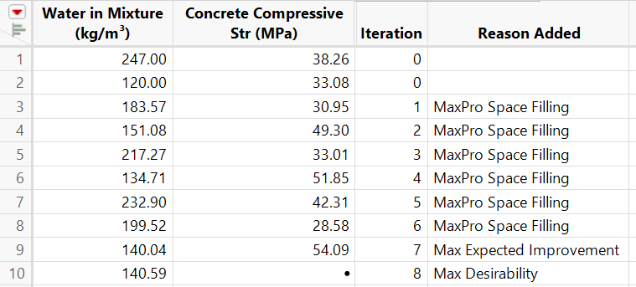
- Close the Bayesian Optimization platform.

- The compressive strength for iteration 8 is 54.14. Add this value to the column Concrete Compressive Str (MPa) where there is a missing value.
After refining the model, Bayesian Optimization has pinpointed a peak where roughly 140.59 kg/m³ of water is used. The column Reason Added transitions to reflect the next stage: confirm and challenge with Max Desirability. In this concluding phase, Bayesian Optimization will make small adjustments and replicate results.

Create the next iteration:
- Click the green play button next to BO Start Up Script for Batch 8.
Add next iteration to the data table:
- Select Batch Selection > Make Table.
- Close the Bayesian Optimization platform.
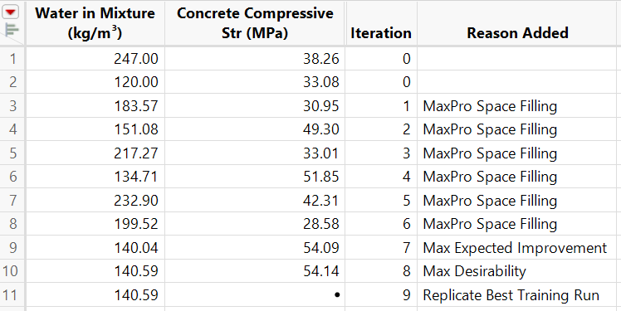

- The compressive strength for iteration 9 is also 54.14. Add this value to the column Concrete Compressive Str (MPa) where there is a missing value.
Notice for iteration 9, Bayesian Optimization simply replicated the previous trial. This is an indication of a maximum.
Findings demonstrate that the maximum concrete compressive strength occurs when 140.59 kg/m³ of water is used in the mixture.
Let’s see what happened:
Following is the final iteration (iteration 9) from the profiler.
- Click the green play button next to BO Start Up Script for Batch 9.
- Click the red triangle next to All Responses Profiler > Data Points.
- Right click over the y-axis, then select Axis Settings. Change the y-axis minimum to 20 and maximum to 55.
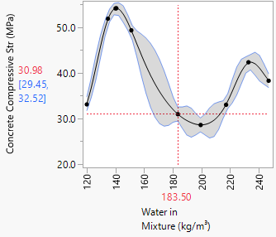
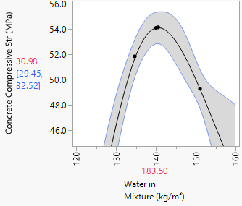

When is the right time to stop?
Although we could run additional iterations to confirm and challenge this result, the outcome reasonably meets goals of the case study. Therefore, iteration 9 is a plausible stopping point. More generally, there is always potential for further refinement through additional iterations; therefore, decisions to stop testing should align with desired objectives of the study.

- Close all windows associated with this case study.
- In the JMP Journal, click Next Case Study.

Key Takeaways:
- Bayesian Optimization can maximize the objective function.
- New iterations are targeted for space filling, model refinement, or confirm and challenge optima.
- Limits iterations by utilizing an active and adaptive learning approach.

Case Study 2: Maximizing Sophorolipid Production

Background:
Sophorolipid biosurfactants are eco-friendly compounds that reduce surface tension between liquids. Their uses include healthcare, nutrition and manufacturing industries. Despite their widespread applications, ingredients that form sophorolipids such as glucose, rapeseed oil, and nitrogen can be costly. Therefore, biotech firms want to determine concentrations of the three feedstocks that maximize sophorolipid synthesis.

In the second application, Bayesian optimization will be utilized with multiple factor variables. Suppose a biotech firm is attempting to produce a biodegradable compound, sophorolipid biosurfactants (g/L), using three ingredients: glucose (g/L), rapeseed oil (mL/L), and nitrogen (g/L). The goal is to determine optimal concentrations of the three ingredients that maximize sophorolipid production.

Goals:
- Use historical data with Bayesian Optimization.
- Optimize a response using multiple factors.
- Demonstrate platform diagnostic features.
- Define response limits.

What concentrations of glucose, rapeseed oil, and nitrogen maximize sophorolipid synthesis?

For this case study, suppose we have historical sophorolipid production data that was collected through initial experiments. These data have already been imported into JMP using the Excel Import Wizard.
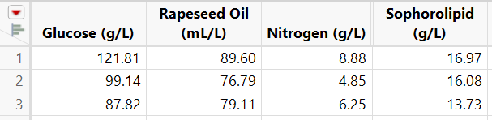
- Data can be accessed by clicking Sophorolipid Synthesis Data in the JMP Journal.

Historical data of three measurements of sophorolipid production with differing ingredient amounts
Factor Variables:
- Glucose (g/L): Mass of glucose per liter of mixture
- Rapeseed Oil (mL/L): Volume of rapeseed oil per liter of mixture
- Nitrogen (g/L): Mass of nitrogen per liter of mixture
Response Variable:
- Sophorolipid (g/L): Measured mass of sophorolipids per liter of mixture
Once the data are imported, it is essential to define a goal for the response when using the Bayesian Optimization platform. Specifying a response goal guides the optimization process and ensures meaningful results.
It is also possible to define response limits. In doing so, Bayesian Optimization will search to find the optimal solution within the provided limits.
For example, the goal and response limits might be as follows:
- Maximize the sophorolipids production within the limits of 25–50 g/L
Specify goal and response limits in JMP:
Sophorolipid (g/L):
- Right click on Sophorolipid (g/L) column header > Column Info > navigate to Column Properties menu > select Response Limits.
- Ensure Maximize is selected from the dropdown window.
- Enter 25 for Lower and 50 for Upper.
- Click OK.

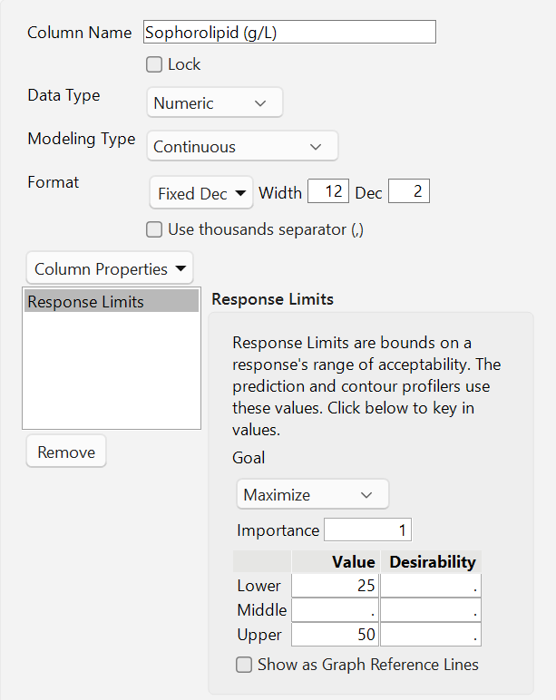

By defining the response limits, Bayesian Optimization will attempt to find the optimal solution within the provided bounds. Outcomes that maximize the response are given a high desirability rating. Bayesian Optimization seeks to maximize desirability according to the response limits specified above.
For the factors, JMP Pro defines the design range for each factor using the minimum and maximum values found in the data table by default. If examining regions outside these defaults is desired, the ranges of interest can be adjusted. Although values may be intentionally constrained, considering exploration beyond the ranges may uncover new insights.
For example, the factor ranges might be as follows:
- 15–180 g/L of Glucose
- 15–180 mL/L of Rapeseed Oil
- 3.5–9 g/L of Nitrogen
In JMP, design ranges can be specified by adjusting Column Properties of the factors and modifying the Coding property.
Specify factor ranges in JMP:
Glucose (g/L):
- Right click on Glucose (g/L) column header > Column Info > navigate to Column Properties menu > select Coding.
  - Enter 15 for Low Value and 180 for High Value.
- Click OK.
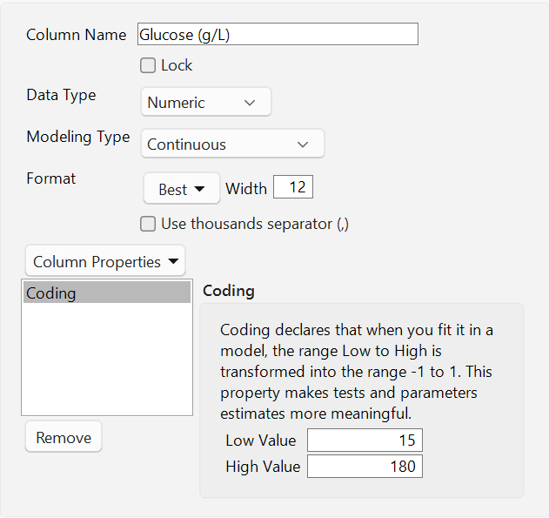

Rapeseed Oil (mL/L):
- Right click on Rapeseed Oil (mL/L) column header > Column Info > navigate to Column Properties menu > select Coding.
- Enter 15 for Low Value and 180 for High Value.
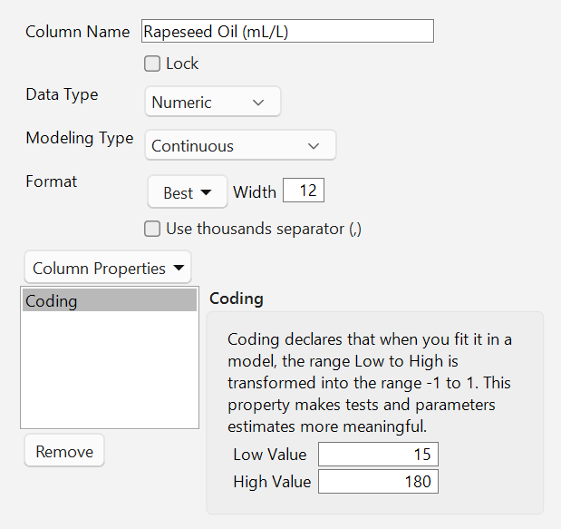
- Click OK.

Nitrogen (g/L):
- Right click on Nitrogen (g/L) column header > Column Info > navigate to Column Properties menu > select Coding.
- Enter 3.5 for Low Value and 9 for High Value.
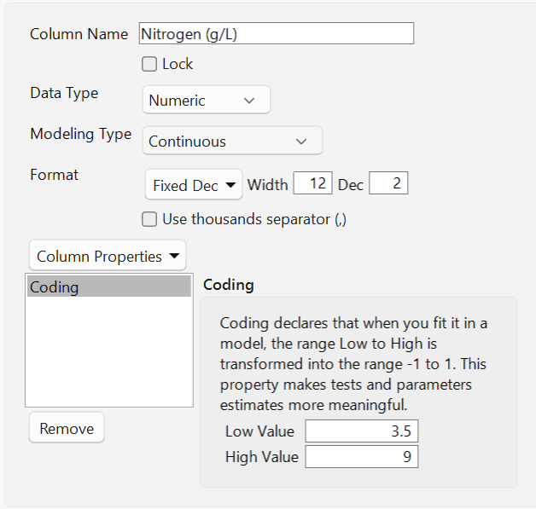
- Click OK.

Caution! Changing the factor settings for explanatory variables ensures Bayesian Optimization will only propose new experimental runs with values restricted in the range.

Set up Bayesian Optimization in JMP:
Let’s use the Bayesian optimization feature in JMP Pro with the three historical observations.
- In the Table Panel, click the green play button next to Set Seed.
- Select Analyze > Specialized Modeling > Bayesian Optimization.
- Select Sophorolipid (g/L), then click Y.
- Select Glucose (g/L), Rapeseed Oil (mL/L), Nitrogen (g/L), then click X.
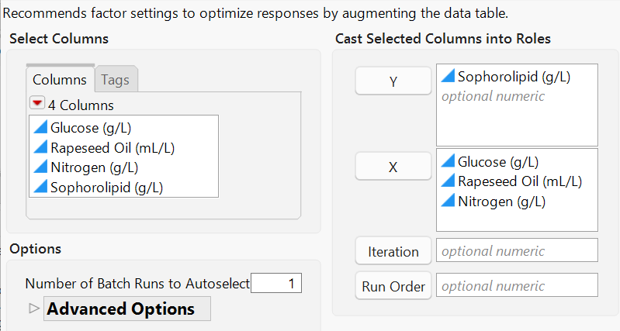

- Click OK.

Add next iteration to data table:
- Select Batch Selection > Make Table.
- Close the Bayesian Optimization platform.
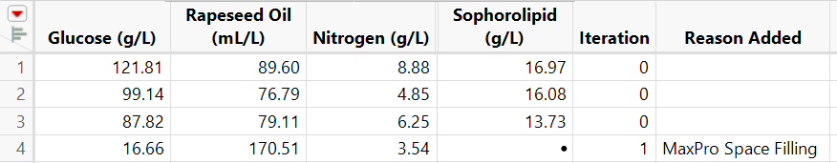

Suppose the production of sophorolipids is 13.63 g/L.
- Add 13.63 to the column Sophorolipid (g/L) where there is a missing value.
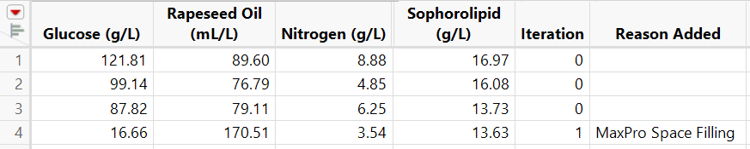
z

Let’s see what happened:
- In the Table Panel (near the top-left corner of data table), click the green play button next to BO Start Up Script for Batch 1.
Under the Model Summary tab, notice that the Leave-One-Out R-square value is below 0.25 (the default minimum). Also, in the desirability plot, we can see the previous iteration had a very low desirability. Why is this?
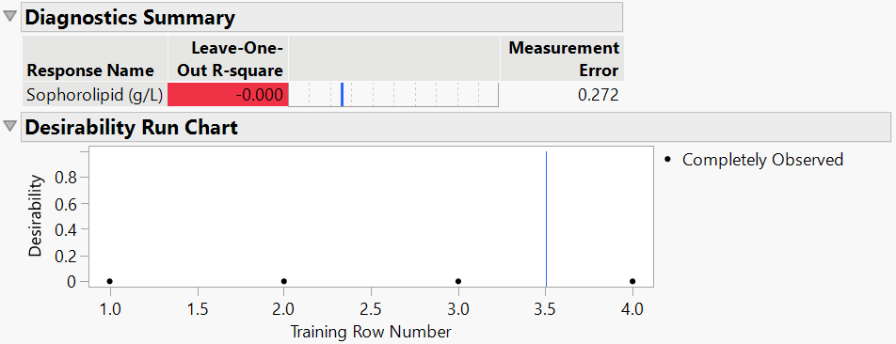

Recall that the first iteration produced 13.63 (g/L) of sophorolipids. When we defined response limits, the minimum response limit was set to 25 g/L. Therefore, this iteration received a low desirability since sophorolipids production was low. Also, the Leave-One-Out R-square is below the general threshold of 0.25. To find a state where sophorolipid synthesis meets goals and has a high desirability, we need more data… space fill!
- Close the data table and Bayesian Optimization window without saving.
- Navigate to the JMP Journal and click Iteration 8.

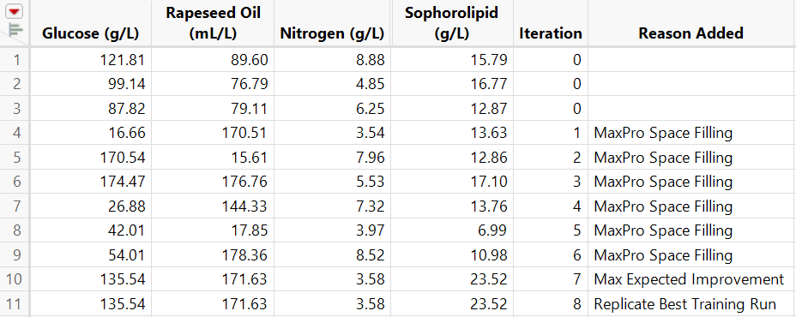

After 8 iterations, space filling, refine the model, and confirm/challenge stages are complete. Notice, Bayesian Optimization focused on a region where there is low nitrogen, roughly 3.5 g/L. Recall the factor limit for nitrogen was set to a minimum of 3.5 g/L. Could we achieve a better result if we reduced this factor setting?
Create the next iteration:
- Click the green play button next to BO Start Up Script for Batch 8.
Open the Augmented Prediction Profiler:
- Select Batch Selection.
- Click the gray triangle button next to Bayesian Optimization Batch Customizer.
- Click the gray triangle next to Augmented Prediction Profiler.
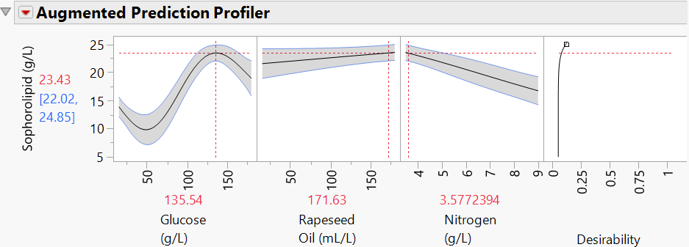

The Augmented Prediction Profiler visualizes how each factor impacts the predicted response, with uncertainty regions. Unlike the All Responses Profiler in the Model Summary tab, the augmented profiler also includes desirability. Shown above, it is evident that there appears to be higher sophorolipid synthesis at low nitrogen levels. Therefore, let’s adjust the factor settings for this variable.
Clicking and dragging any red vertical dashed line of the prediction profiler will automatically adjust the factor settings in the Bayesian Optimization platform. For specific limits:
- Click the red triangle next to Augmented Prediction Profiler > Optimization and Desirability > Optimization Control Panel.
- Select Factors tab (in the Optimization Control Panel, just below the Augmented Prediction Profiler).
- Change Lower Limit for Nitrogen (g/L) to 0.12 g/L.
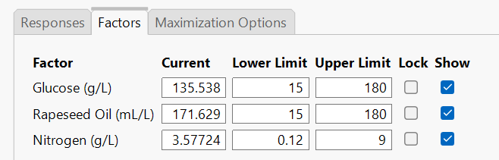
z

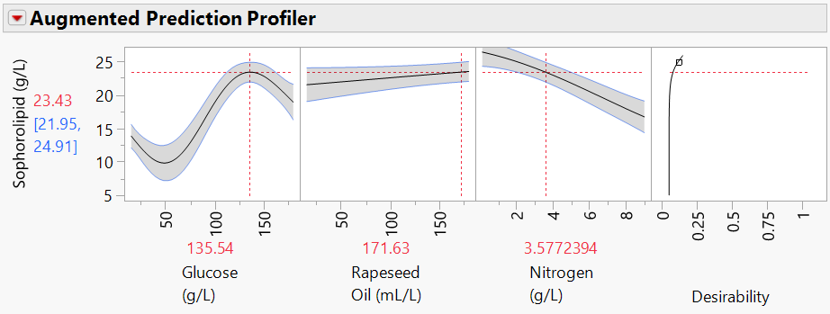
After altering the lower limit, the prediction profiler updates for nitrogen and includes a region that was previously unexplored. To proceed with the next iteration, we need to update Bayesian Optimization and specify that the updated nitrogen range should be utilized.

The factor ranges for Nitrogen (g/L) expanded to include a larger region.
Note: Altering the factor limits in Bayesian Optimization does NOT change the factor settings first specified in the column properties. The platform will now ignore the column properties and only utilize ranges from the prediction profiler.
Click the red triangle next to Bayesian Optimization Batch Customizer.
- Select Generate Candidate Set from Profiler Settings.
- Click OK.
This will create a new iteration of Bayesian Optimization which can be added to the data table.
- Select Make Table.
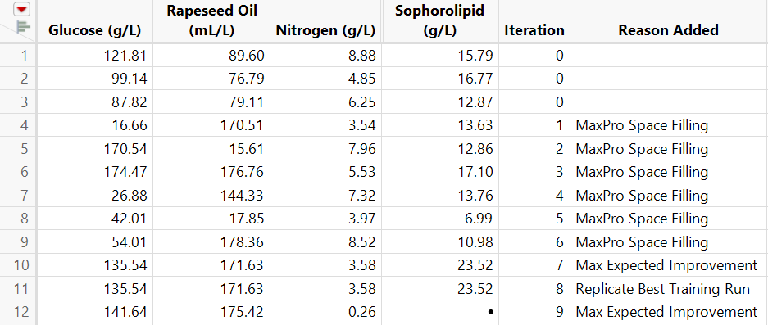

(Iteration 9 generated by Bayesian Optimization may vary from the image above)
Iteration 9 of Bayesian Optimization demonstrates how altering the range of Nitrogen (g/L) impacts the optimum response. Notice how it revisits the model refinement stage after previously confirming/challenging the optima. This flexibility enables goals to be changed while using the platform, without starting over. Let’s see how it adapts in the following iterations.
- Close the data table and Bayesian Optimization window without saving.
- Navigate to the JMP Journal and click Final Iteration.
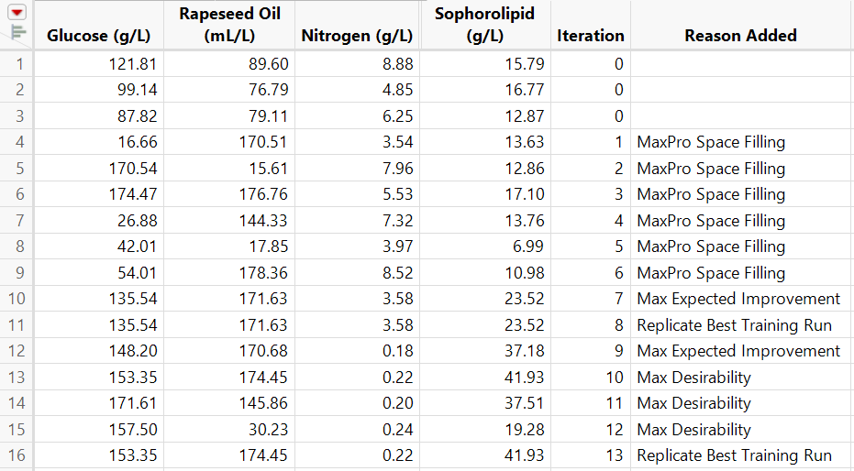

After 13 iterations, notice how a maximum occurred with high glucose, high rapeseed oil, and low nitrogen amounts. The resulting maximum was 41.93 g/L of sophorolipids.
Let’s see what happened:
Let’s examine the diagnostic plots for the final iteration under the Model Summary tab.
- Click the green play button next to BO Start Up Script for Batch 13.
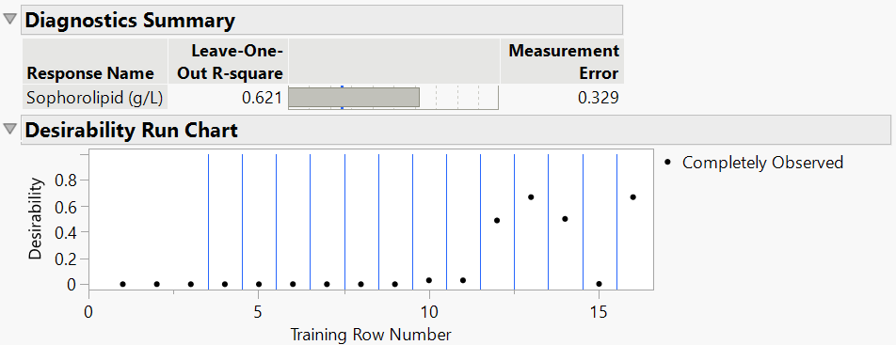

Early iterations had a low desirability, which resulted in extensive space filling steps. Final iterations and model refinement steps generally produced a suitable amount of sophorolipids (between 25 and 50 g/L) thus increasing the desirability of the response.
Lastly, let’s examine the combinations of ingredients (glucose, rapeseed oil, and nitrogen) that produced the most sophorolipids.
Visualize Results:
- Close the data table and Bayesian Optimization window without saving.
- Navigate to the JMP Journal and click 3D Ingredients Plot.
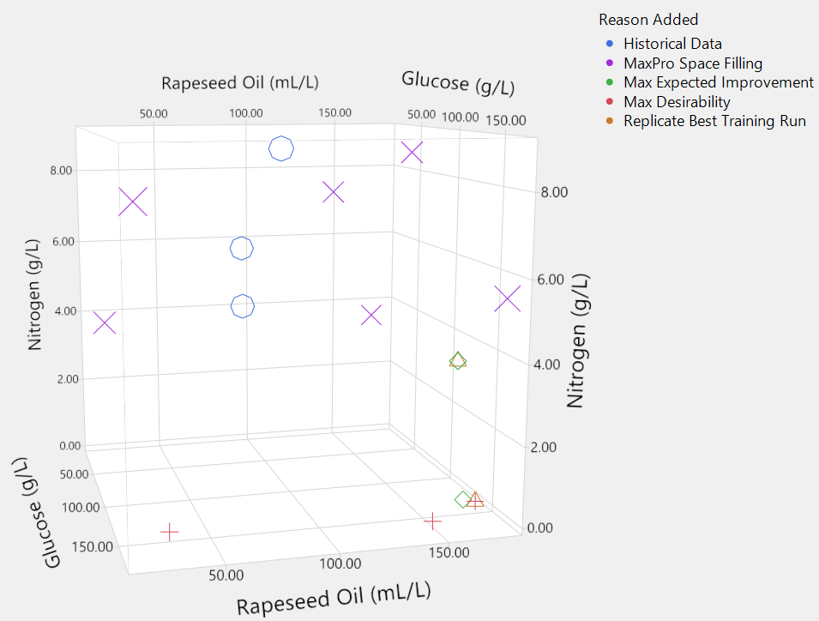

Points on the 3D scatterplot shown in blue circles represent the historical data, purple X display the space filling, and green diamonds display the model refinement step, and red + and orange triangles represent the confirm/challenge stages.
Shown above, data from previous experiments are distant from the optimum. Although the initial data might seem “uninformative” and “irrelevant” to the results, they allowed Bayesian Optimization to effectively inform future trials.
Notice the expected improvement runs (green diamonds) did NOT investigate regions close to the historical data. Instead, they traversed alternate areas of the 3D space to identify where a better maximum resides, in this case, locations where there was high glucose, high rapeseed oil, and low nitrogen.
This key insight allows previous experimental data to be used, even if they have a low desirability. No more cold starts!

Instructions on how to create the 3D scatterplot can be found at the end of this document.

- Close all windows associated with this case study.
- In the JMP Journal, click Next Case Study.

Key Takeaways:
- Factor and response limits should reflect goals of the study. Both can be altered while using Bayesian Optimization to explore new regions.
- Historical data can be utilized, even if data are far from the optimum.
- Bayesian Optimization can support multiple explanatory variables.

Case Study 3: Potency and Size of Lipid Nanoparticles

Background:
Lipid nanoparticles (LNP) are small, fat-based carriers that transport genetic materials throughout the body. Researchers have shown interest in using lipid nanoparticles as a carrier for medicinal drugs. Specifically, pharmaceutical companies want to optimize LNP formulations by adjusting the ratios (must sum to 1) of PEG lipid, helper lipid, structural lipid, and ionizable lipids while also considering other variables.
In the final case study, Bayesian optimization will be used with multiple response variables across mixed factor types. A pharmaceutical firm aims to maximize potency while maintaining a target lipid nanoparticle diameter. Researchers must balance the proportions of four lipidic components amid other categorical and continuous formulation components.

Goals:
- Find optimum of two response variables with unique goals.
- Use mixture factors where the ratios must sum to one.
- Use both categorical and continuous factor variables.
- Demonstrate advanced features of Bayesian Optimization.

What ratios of four lipidic components and formulation parameter configurations maximize potency and match a target diameter of lipid nanoparticles?

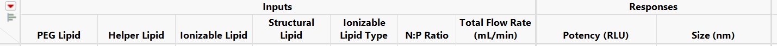

Factor Variables:
- *PEG Lipid: Proportion of polyethylene glycol lipids in the mixture
- *Helper Lipid: Proportion of helper lipids in the mixture
- *Ionizable Lipid: Proportion of ionizable lipids in the mixture
- *Structural Lipid: Proportion of structural lipids in the mixture
- Ionizable Lipid Type: Type of ionizable lipid used in the mixture
- N:P Ratio: Nitrogen-to-Phosphate ratio
- Total Flow Rate (mL/min): Combined volumetric flow rate in milliliters per minute
* Indicates a mixture factor
Response Variables:
- Potency (RLU): Potency of the treatment measured in relative luminescence units
- Size (nm): The diameter of the lipid nanoparticle

In this example, suppose we do not have historical data and need to collect preliminary responses. Bayesian Optimization requires at least one observation to use the platform. To ensure the mixture factors are carefully considered when collecting initial data, the Design of Experiments is a convenient option. When using Bayesian Optimization with DOEs, Space Filling Designs are recommended for collecting initial data.
Using DOE Platform:
- In the JMP Journal, click DOE Dialog.
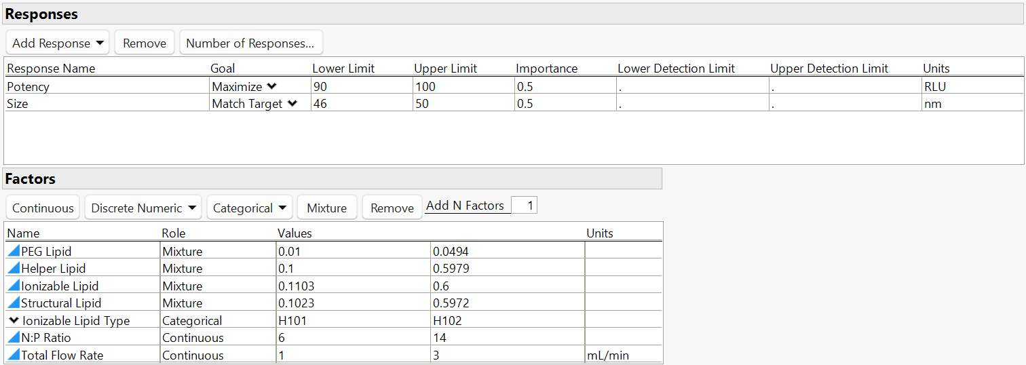

Notice how the goals of the study are reflected in the DOE response Upper Limit and Lower Limit. We want to maximize Potency (RLU) between 90-100 RLU and simultaneously match a target Size (nm) between 36-40 nm (aiming for 38 nm).
The factors in this case study also have unique bounds stored in the Values columns. Additionally, the four mixture factors are designated in the Role column. These variables must be carefully considered as they must always sum to one. Bayesian Optimization will follow all specified properties and limits shown in the DOE platform.
- In the DOE Dialog menu, click Continue.
For this example, suppose we conduct 6 experimental runs using DOE as starting data for the Bayesian Optimization platform.
- Type 6 for Number of Runs.
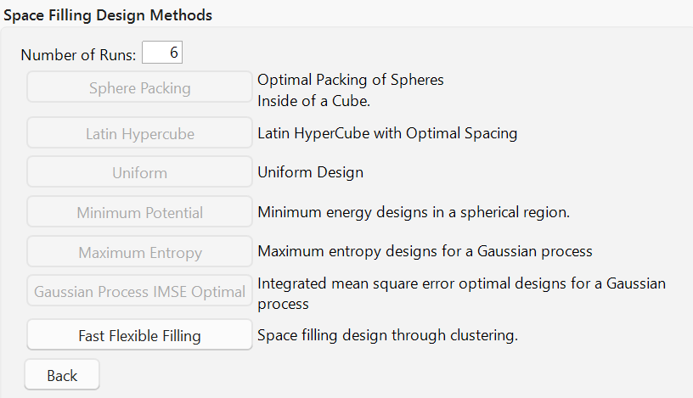
z

- Click Fast Flexible Space Filling.
- Click Make Table.
The following table is produced:
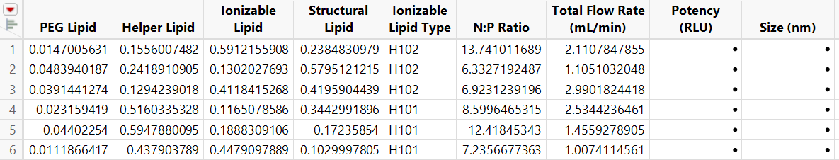

This table provides initial experimental runs provided from the Fast Flexible Space Filling DOE. In practice, the six runs would be conducted and results for Potency (RLU) and Size (nm) would be recorded.

- Close the data table and DOE window without saving.
- Navigate to the JMP Journal and click Lipid Nanoparticles Data.
We will resume with the six-trial DOE and four iterations of Bayesian Optimization complete.
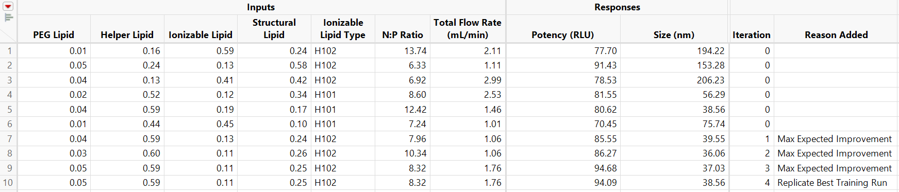

The table contains the six rounded values of the runs designated in DOE and the following four runs using Bayesian Optimization.
Notice the platform did not begin with space filling, instead, it immediately transitioned to the model refinement phase. Bayesian Optimization determined that initial runs generated by the Fast Flexible Space Filling design adequately traversed the space. Integrating processes from both platforms can be advantageous by potentially reducing space filling.
In the final iteration of Bayesian Optimization, the platform determined proportions of 0.05 PEG Lipid, 0.59 Helper Lipid, and 0.11 Ionizable Lipid maximized Potency (RLU) and matched a target for Size (nm). For the other formulation components, the ionizable lipid type was set to H102, N:P ratio 8.32, and total flow rate to be 1.76.
Let’s see what happened:
- Click the green play button next to BO Start Up Script for Batch 4.
Let’s observe diagnostics from the final run.

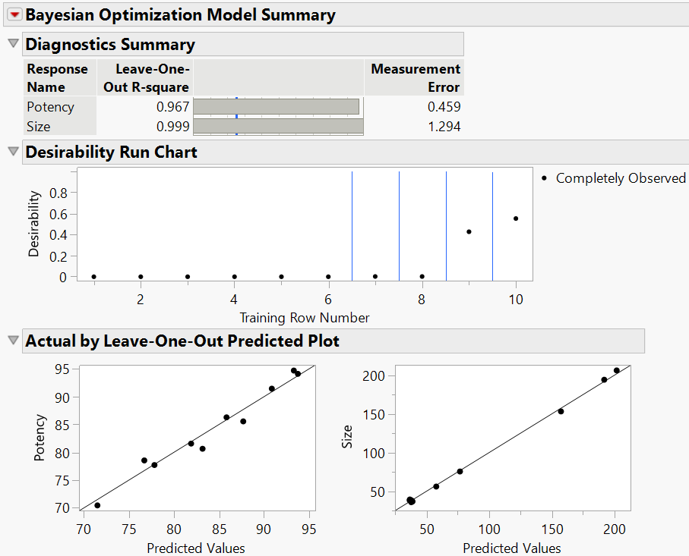

Key insights from the platform visualizations indicate high Leave-One-Out R-square values for potency and size outcomes. Additionally, the final run had the highest desirability. Finally, the Actual by Leave-One-Out Predicted Plot demonstrates the data are close to the line y=x, indicating favorable prediction accuracy.
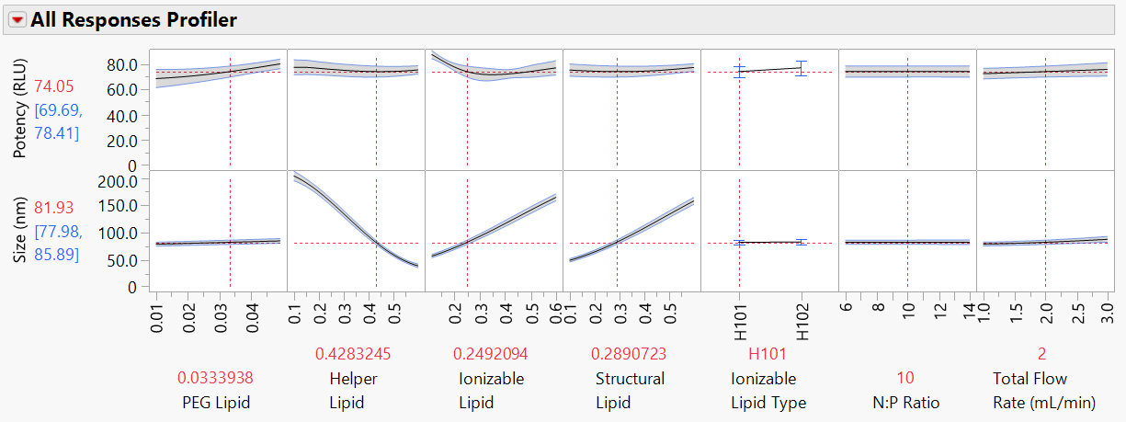
Also, visualizations in the platform now account for two response variables. For example, the All Responses Profiler, found at the bottom of the Model Summary tab, contains two rows to accommodate each response.

Notice Bayesian Optimization supports categorical variables with multiple levels, as seen in the profiler above.
Let’s also examine how the Bayesian Optimization platform was able to account for the mixture factors.
Visualizing Results:
- Close the data table and Bayesian Optimization window without saving.
- Navigate to the JMP Journal and click Mixture Factors Dashboard.
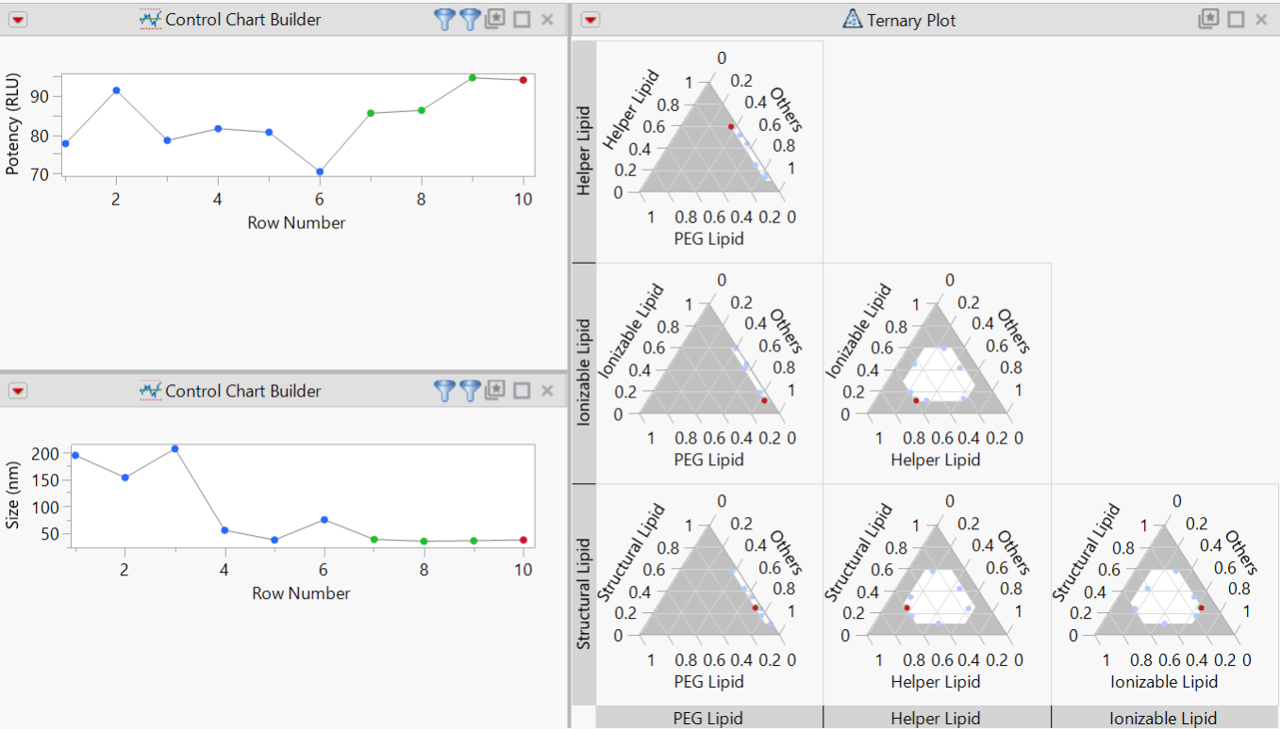

The dashboard shows the two responses and their values for each row number, and a ternary plot for the mixture factors. Notice the plots adapted since there were four mixture factors that must sum to one. The combinations of two factors and a third axis for “Others” is created.
The point highlighted in red is the optimum determined Bayesian Optimization. From this plot, we can make several key insights. Primarily, the optimum occurred where there was a high proportion of helper lipid, low proportion of structural lipid, and very low proportion of PEG and ionizable lipids. Bayesian Optimization seamlessly accounted for the mixture factors along with additional formulation parameters.
Instructions on how to create the ternary plot can be found at the end of this document.

- Close all windows associated with this case study.

Key Takeaways:
- Bayesian Optimization supports multiple outcomes with different goals.
- Flexible modeling types for factor variables.
- Platform integrates with DOE and mixture factors, enhancing experimental design.

Optional Scatterplot Instructions (Sophorolipid Synthesis)
Instructions to make the scatterplot. Primarily, edit the Reason Added column for the initial three data points. Type Historical Data into the columns.
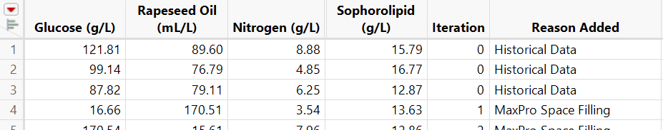

Next, let’s add shapes to the rows that correspond to each Reason Added category.
- Select Rows > Color or Mark by Column.
- Select Reason Added column.
- Colors: None.
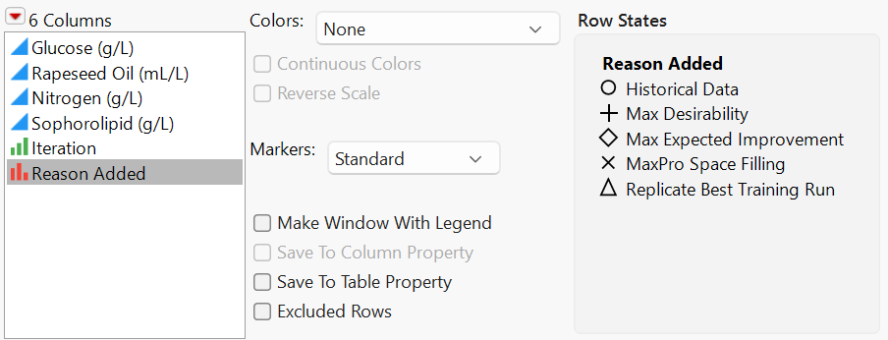
- Markers: Standard.

- Click OK.
Notice each row in the data table is assigned a shape based on the Reason Added Column.
Creating the 3D scatterplot:
- Select Graph > Scatterplot 3D.
- Select Glucose (g/L), Rapeseed Oil (mL/L), and Nitrogen (g/L), then click Y, Columns.
- Select Reason Added, then click Coloring.

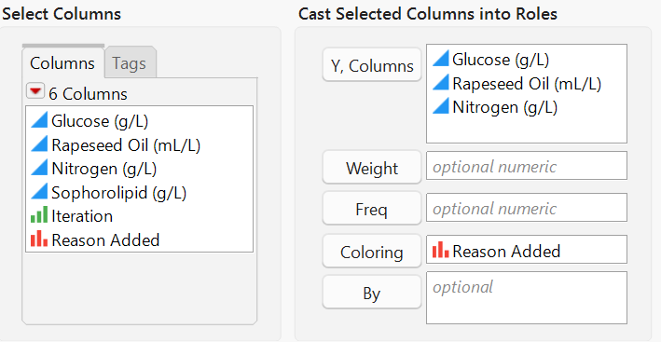

- Click OK.
The size of the markers can be increased by right clicking on the scatterplot > Settings > drag Marker Size slider, then click Done.
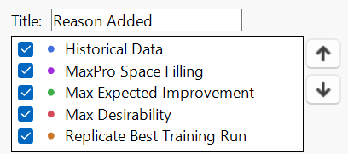
Finally, the order of the legend can be adjusted to reflect the sequential stages of Bayesian Optimization. Right click on the legend > Legend Settings. Use up/down arrows to position labels into the desired order, then click OK.

Final Visualization:
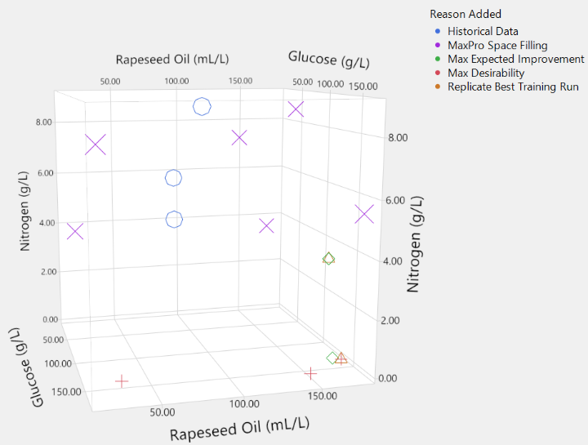

The graph can be rotated by clicking and dragging inside the scatterplot. It will continually rotate by holding shift and dragging in the desired direction of rotation.
Optional Ternary Plot Instructions (Lipid Nanoparticles)
First, color rows in the data table based on the column Reason Added. The final iteration can be marked with the color red.
To assign colors to selected rows:
- Select desired rows.
- In the row header region, right click > select Coloring > click color of choice.
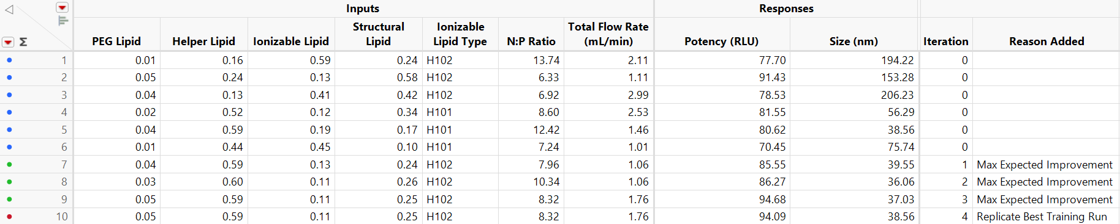

Creating the ternary plot:
- Select Graph > Ternary Plot.
- Under Inputs, select PEG Lipid, Helper Lipid, Ionizable Lipid, and Structural Lipid then click X, Plotting.
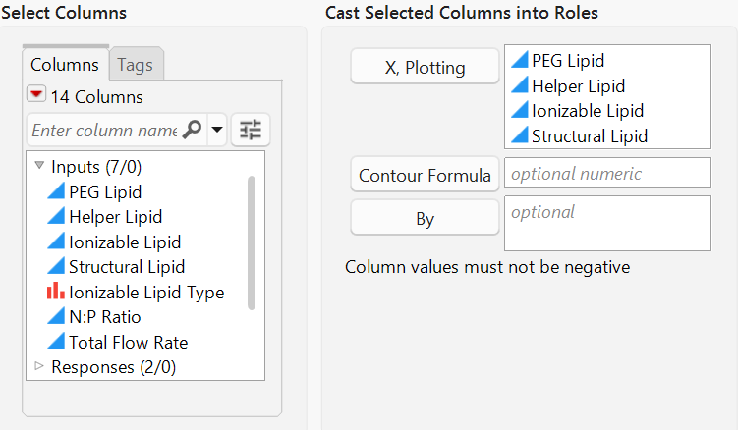

- Click OK.

The following visualization is produced:
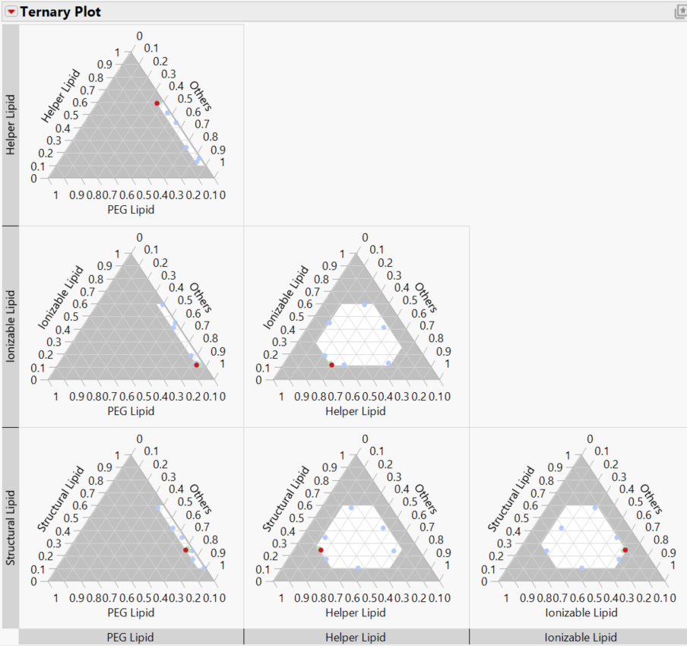

If the visualization is too large, click the red triangle next to Ternary Plot > Fit to Window > On. The red data point can be selected by clicking on it in the plot or by selecting the row in the data table.

