Custom Date Formula Writer Instructions

To install the stand-alone add-in, select File > Open from JMP’s main menu, and select the Custom Date Formula Writer.jmpaddin file. (Alternatively, open the Data Table Tools.jmpaddin, which contains the Date Formula add-in along with many others.)

A menu option to access the add-in will be added to the Add-ins menu, which will be created if it does not already exist.

To run the add-in, select it from the Add-ins menu.

After running the add-in, select a data table and the date column from the top two panes in the window. At any time, you can refresh the list of tables by pressing the Refresh table list button.

Upon selecting the date column, the text in the first row of the column is displayed in the lower pane of the window. In this example, select the Long Dates table (available for download on the same page from which you downloaded the add-in) and its Date and Time column.

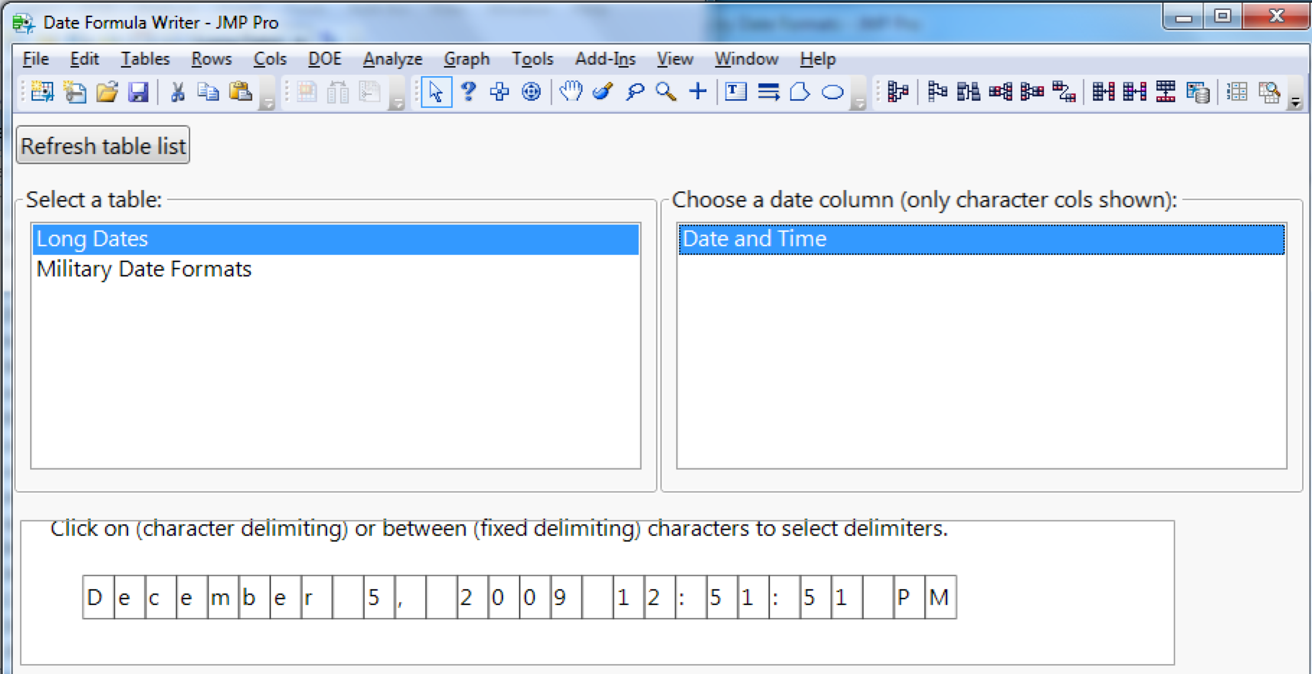

If the radio button for Character delimiting is selected, clicking on a character will treat it as a delimiter, coloring it and all matching characters blue. (Simply click again to reverse your decision.) Here, a space has been clicked, so all spaces are treated as delimiters and colored blue.

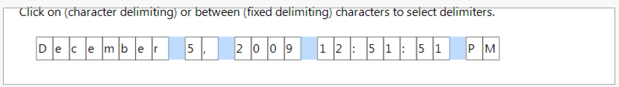

Select a space character, the comma, and one of the colons, after which the text should appear as below. Press the Apply delimiting and choose words button to proceed.

Make the other selections shown below (altering the Display format selection if desired) and press Build Formula Column to create the new column.

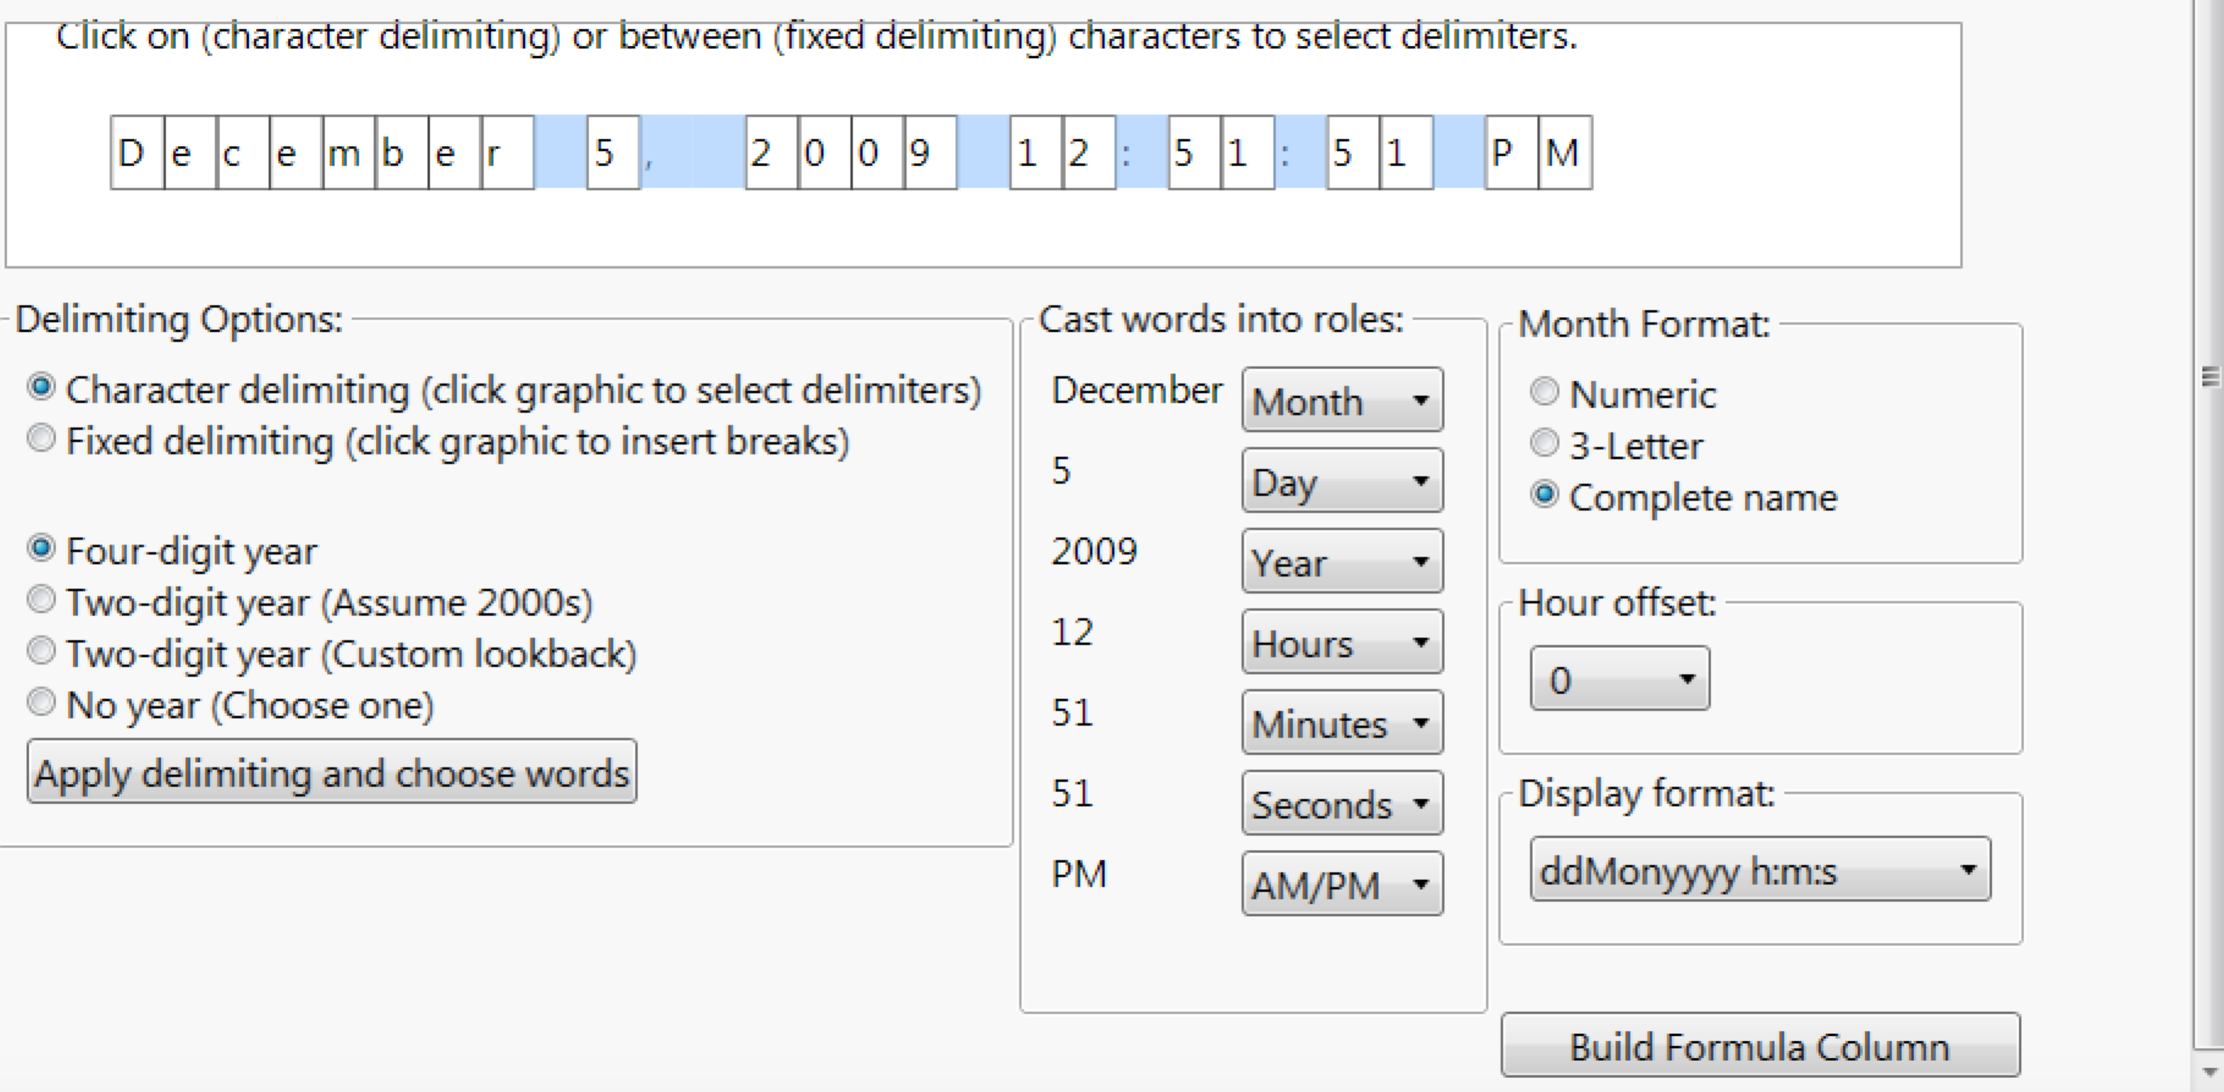

The new column is created in the data table.

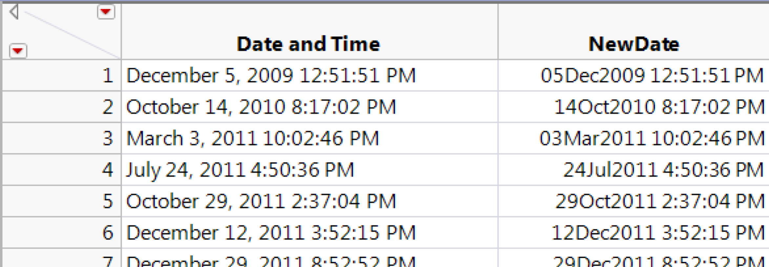

Clicking on the “+” in the table’s columns panel reveals the formula. Double-click it to see it in the script editor:

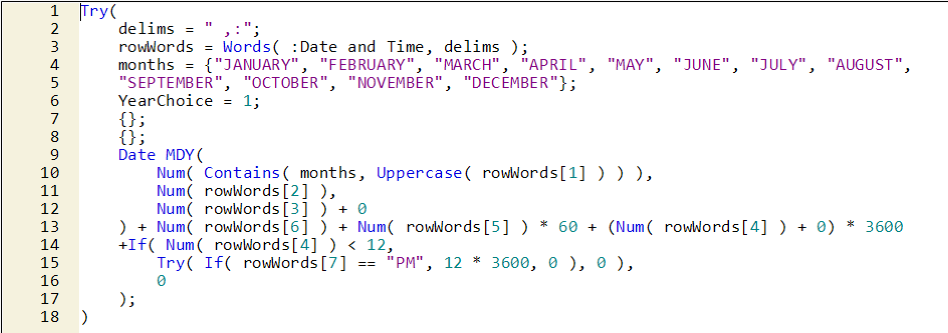

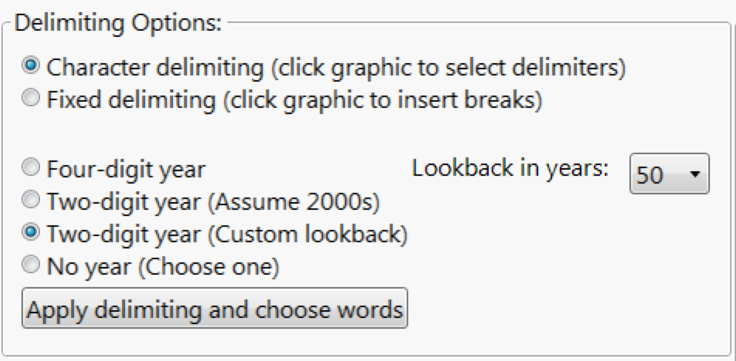

A note about the custom lookback option for two-digit years: the lookback value tells JMP how far in the past the earliest date can occur. For example: using a 70-year lookback (for a formula columns created in 2016) means that 2-digit years will resolve to years between 1946 and 2045, inclusive.

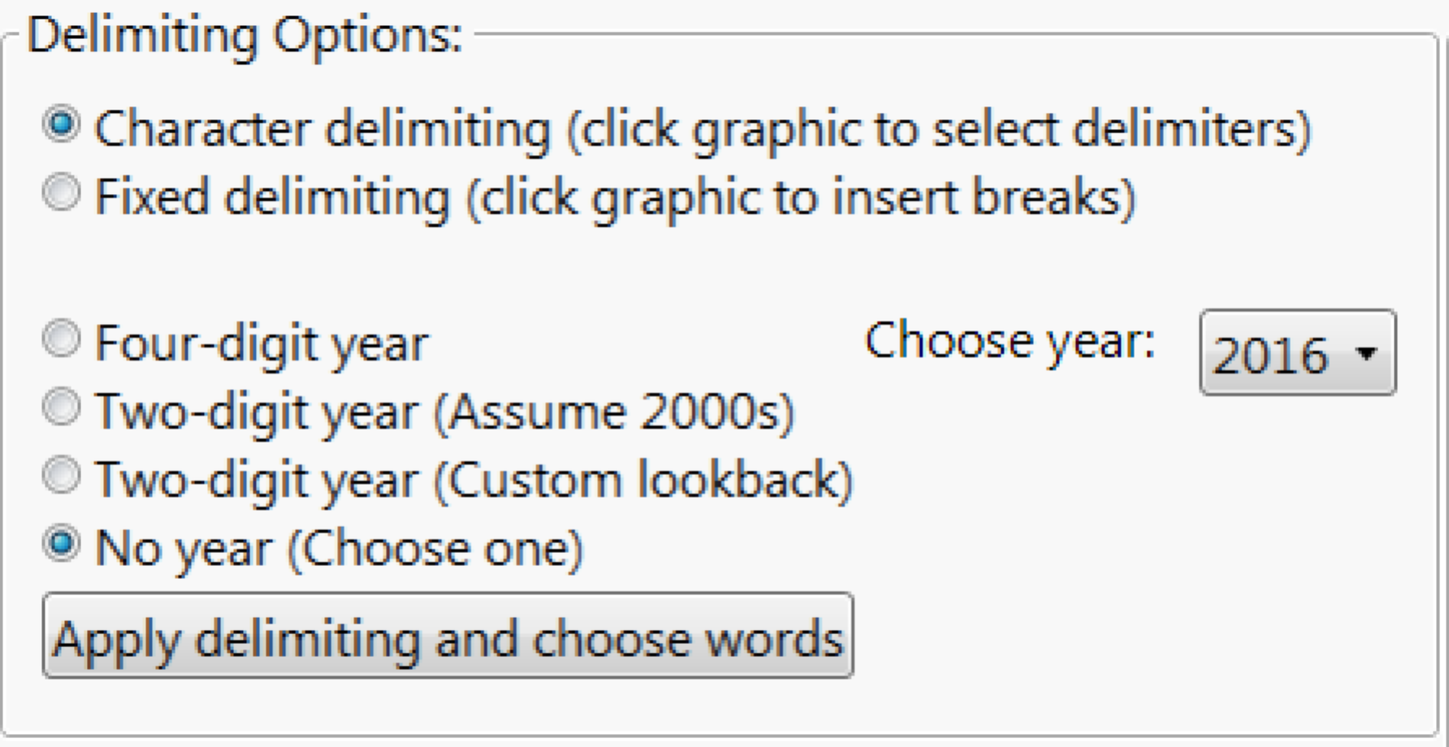

When “No year” is selected, a drop-down menu appears, allowing you to choose the year, which will be the same for all dates in the column.

For another example, choose Column 1 in the Military Dates Formats table (downloadable from the same location as the other two files). This column’s dates have fixed delimiting—that is, the fields appear in the same character positions in every string.

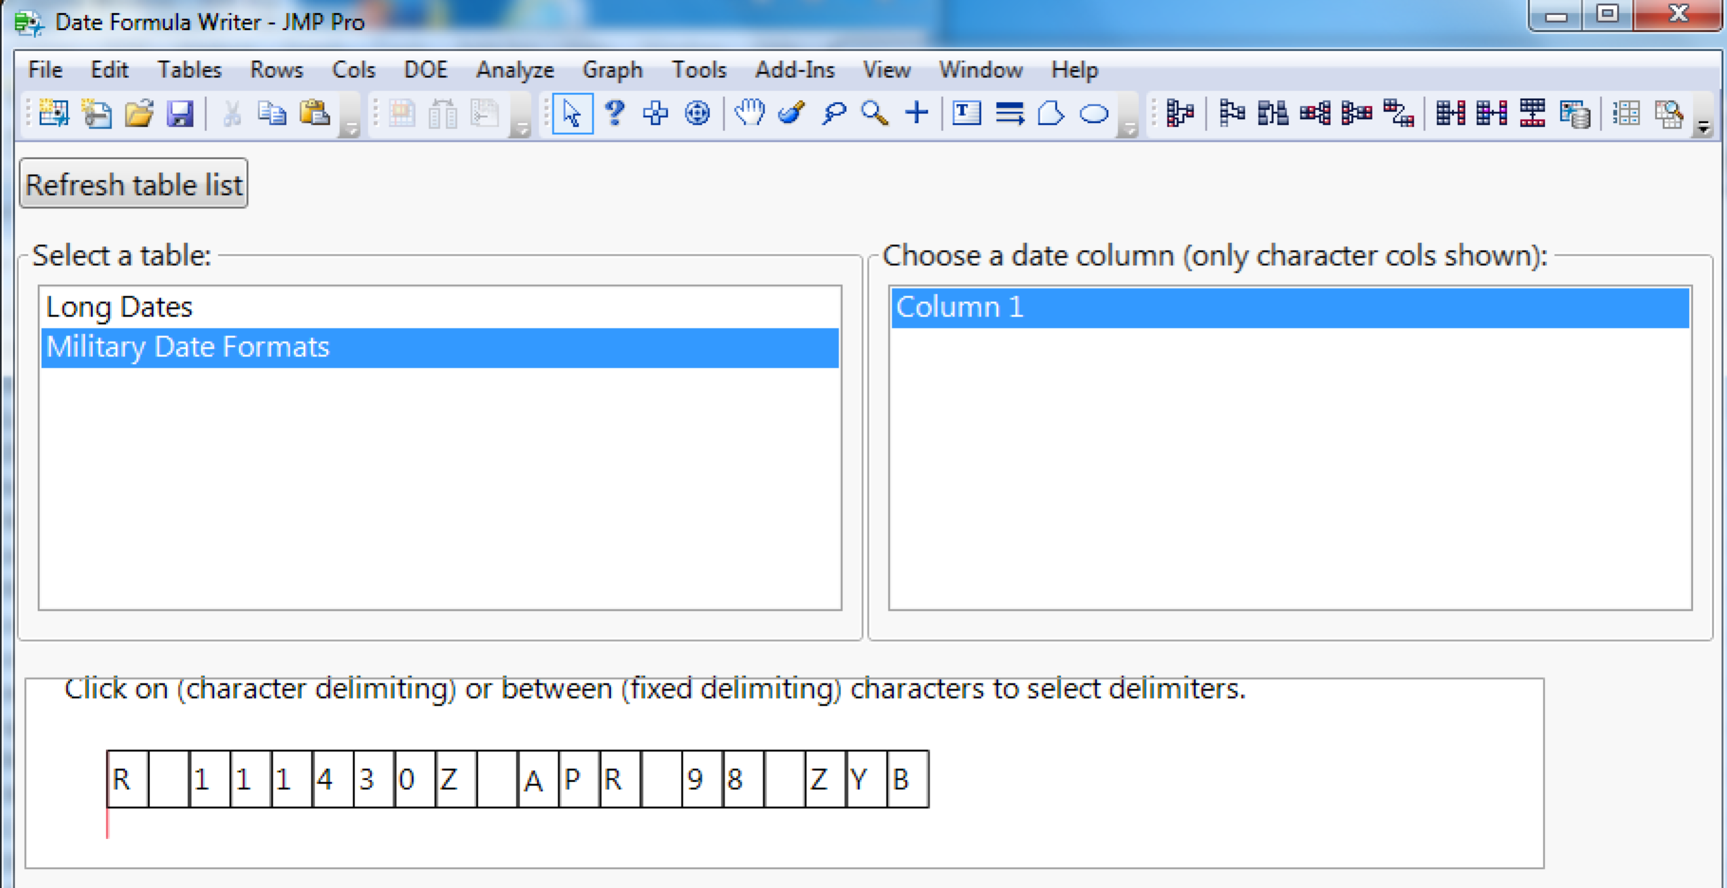

Select the Fixed delimiting option. When this option is selected, clicking will insert (or remove) red tick-marks between the characters. Tick-marks must be placed at the beginning and end of each field. (Note that the tick-mark at the beginning of the string is always present, and cannot be removed—this is as intended.)

After clicking the text to place the separators as shown below, press the Apply delimiting and choose words button.

Make the selections shown below, then press the Create formula column button.

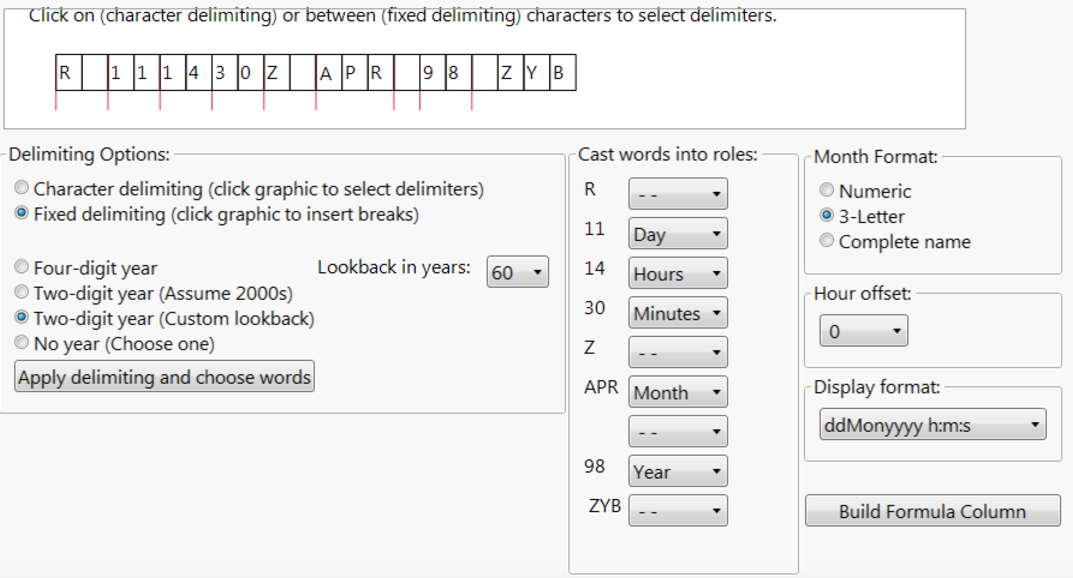

The formula column is created; inspection of the formula reveals that, as in the previous example, devising and entering the formula manually would have been rather tedious and error-prone.

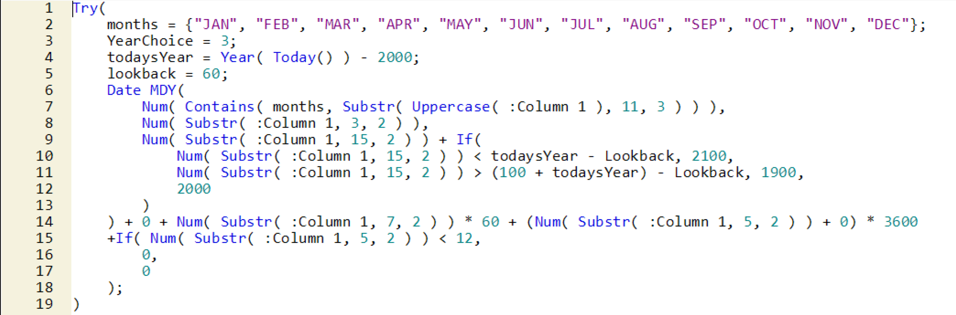

Change the lookback value to 80, and create another new column. Notice that with a 60-year lookback, an entry of 38 represents the year 2038, but with an 80-year lookback, 38 represents the year 1938.

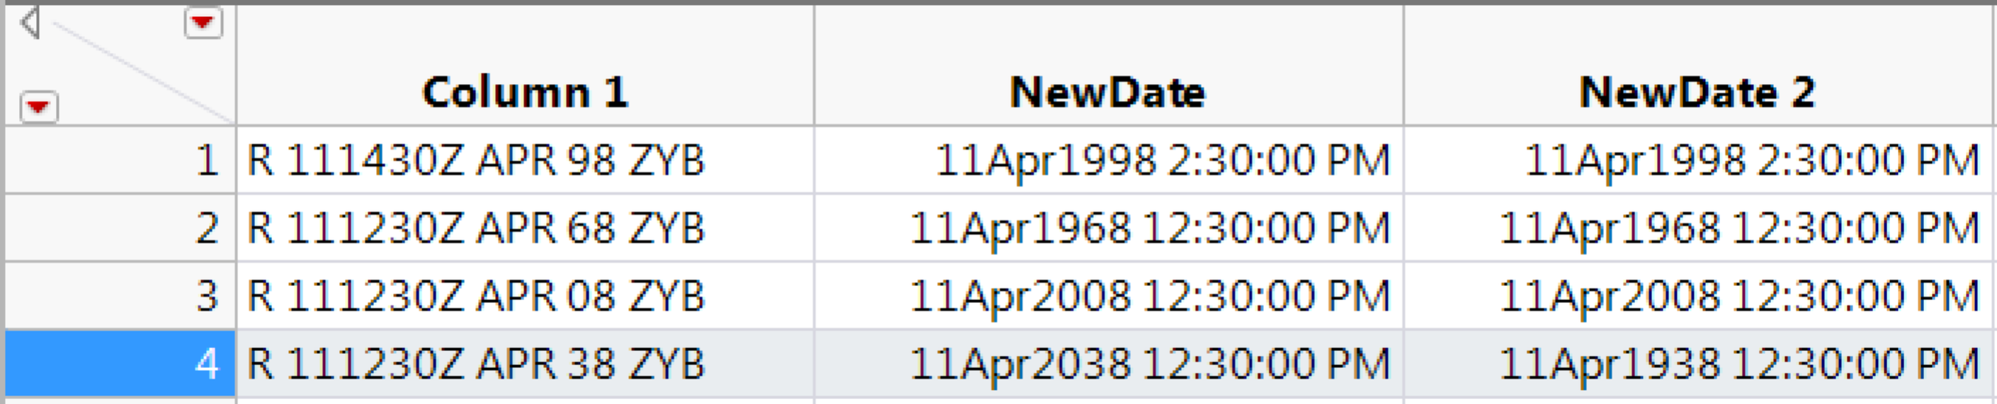

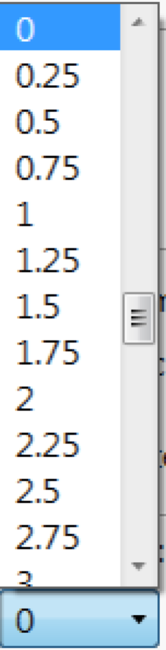

The Hour offset drop-down (0 in both of our examples) allows you to adjust all times by the specified number of hours—for example, when you want to render the original times in another time zone.

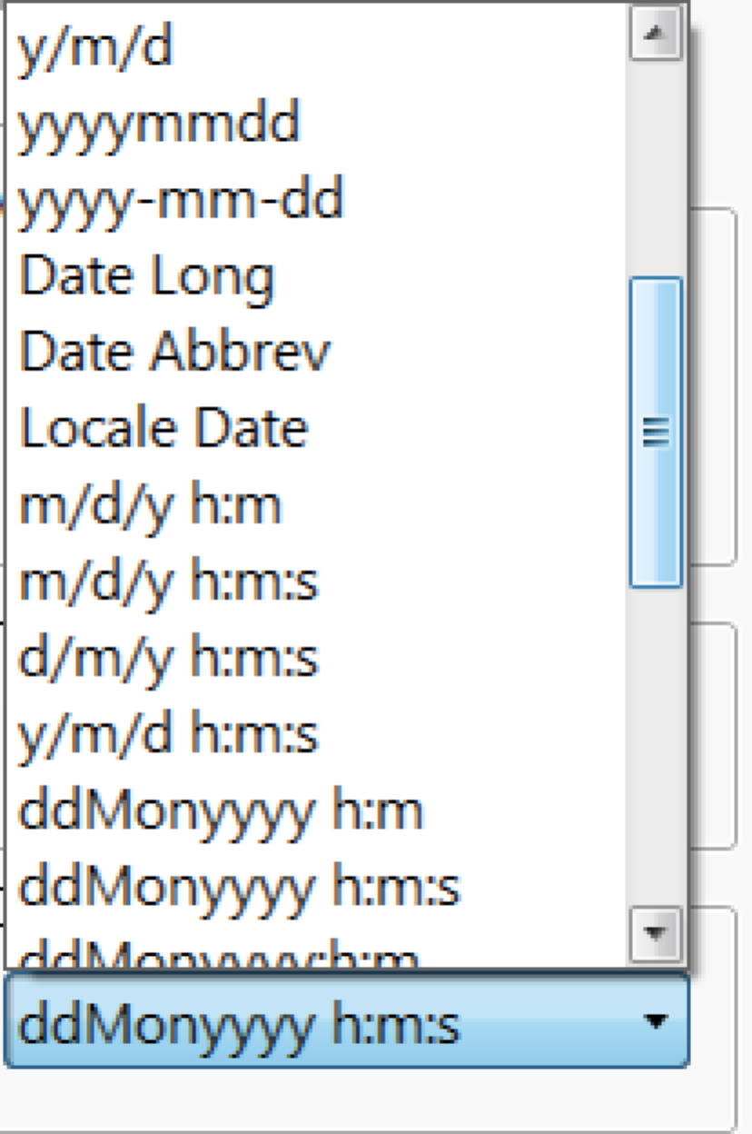

While it does not affect the formula written to the new column, the Display format drop-down allows you to conveniently set the new column’s format.

