Applications of Dynamic Regression Models in Business and Industry
By
Robert M. Lucas, PhD.

Introduction
Dynamic regression models extend multiple regression models by allowing for independent variables to be incorporated as leading indicators of the dependent variable and to account for autocorrelation of the dependent variable. Dynamic regression models can be built in the JMP® Time Series Platform.
Manufacturing processes data is often a time series with process input characteristics and the final output quality varying over time. A dynamic regression model may be used to ascertain how to adjust process parameters to control the variability of process output quality.
In business, market mix models are used to evaluate the return on investment of different advertising strategies. A dynamic regression model can be used to evaluate the return on investment of advertising spend by different media, a market mix model. One can use the model to more efficiently allocate advertising budgets.
Background
A simple example of a multiple linear regression model is given by the following equation.
$$Y=β_{0}+β_{1}X_{1}+β_{2}X_{2}+ε$$
The model assumes that the mean of the response given the independent or input variables can be represented by a linear combination of the inputs. It also assumes that the deviations of the observed values from the mean represented by the error term are independent and normally distributed with a mean zero and constant variance.
A comparable time series regression model is represented by the following equation.
$$Y_{t}=β_{0}+β_{1}X_{1t}+β_{2}X_{2t}+ε_{t}$$
The only difference in notation is the inclusion of the subscript t. However, this implies that the order of the data is important. The data must be sorted from oldest to the most recent observation and must have equally spaced time intervals between the observations, a time series.
Dynamic regression models are an extension of multiple linear regression. One extension is to accommodate the situation when the deviations from the mean are not independent but correlated. The other extension is to have more complicated relations between an input and the response. The equation below represents both of these extensions.
$${(1-θ_{1}B)(Y}_{t}-β_{0}-β_{1}X_{1t}-β_{2}X_{1\left(t-1\right)})=ε_{t}$$
The Backward Shift Operator, B, is defined as
$${B(Z}_{t})=Z_{t-1}$$
JMP® uses the equivalent expression below.
$$Y_{t}=β_{0}+β_{1}X_{1t}+β_{2}X_{1\left(t-1\right)}=(1/{(1-θ_{1}B))ε}_{t}$$
The response depends on both the current value of the input and on the previous value of the input. The response also depends on the previous value of itself. Consequently the term autocorrelation, correlation with itself.
Models like these can be fit in the JMP® Time Series Platform using the Transfer Function Specification window. The term transfer function is natural. The function describes how variation in the input is transferred to the response.
Manufacturing Process Description
A pharmaceutical manufacture of over-the-counter medications sells a product in 6 fluid ounce bottles. Because the viscosity of the product depends on ambient temperature, bottles tend to contain more product when temperatures are higher, and less when cooler. The space is conditioned but the temperature still varies by time of day. Fill volume can be adjusted by controlling the speed of the pump. The filling line fills 12 bottles about every five seconds. The target is set about 6.15 ounces to essentially eliminate the chance of under fill.
This demo illustrates how one can quantify the relationship among temperature, pump speed, and fill volume. Once quantified, the variability of fill volume can be reduced by adjusting the pump speed to compensate for changes in temperature that affect the viscosity of the product. With less variability, the target fill volume can be reduced with very small chance of under fill. Hence, substantial saving can be attained by reducing the average fill volume.

Manufacturing Process Data Demonstration.
A subset of the manufacturing process data table is show below.
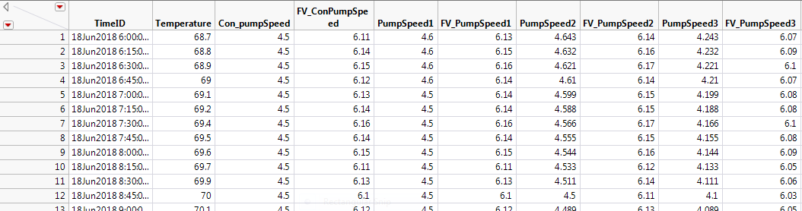
The data table contains nine columns. The first column is the TimeID, a JMP® date-time value in 15 minute increments. Temperature is degrees Fahrenheit of the plant. The column FV_ConPumpSpeed is the fill volume in fluid ounces of the product when the pump speed does not vary. The pump speed is gallons per minute. To ascertain the effect of pump speed and temperature, pump speed was varied as a function of temperature as shown in the PumpSpeed1 column. The measured fill volumes as given in the FV_PumpSpeed1 column. The PumpSpeed2 column gives the adjusted pump speed based on the results of the experiment. FV_PumpSpeed2 gives the fill volumes for PumpSpeed2. Because the variability of the process was reduced, the average pumps speed can be reduced as shown in the PumpSpeed3 columns. The FV_pumpSpped3 column contains the measured pump speed for PumpSpeed3.
The above data are simulated but realistic based on the actual process. The realism was confirmed by my anonymous source of the process details.
To open the Time Series Platform, select Analyze, then Specialized Modeling, and then Time Series. The Time Series dialog opens.

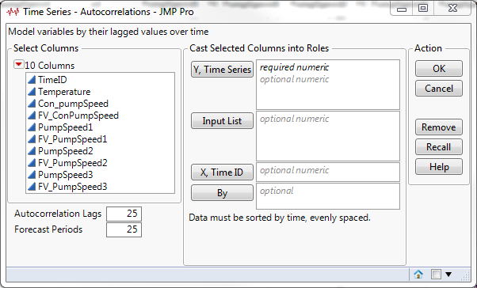
Assign the columns to their roles as show below.
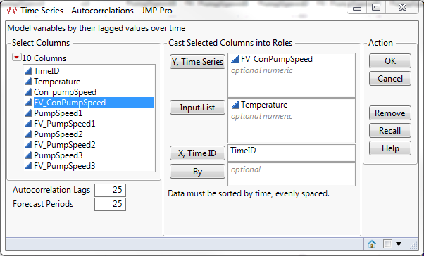
After selecting OK, the following graphs appear.
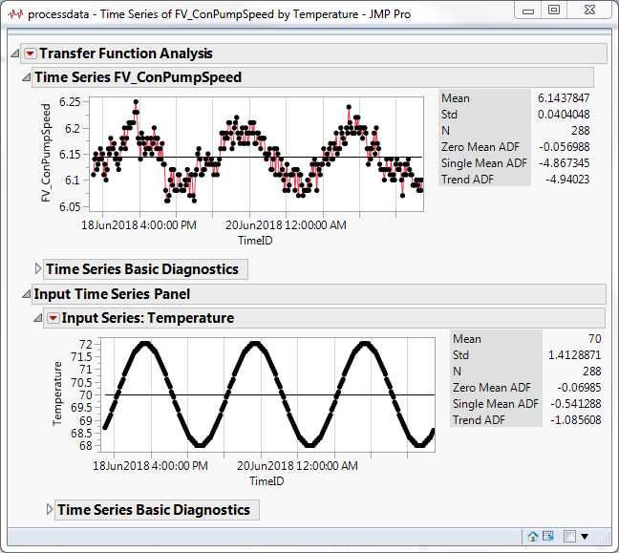
Obviously, fill volume and temperature are highly correlated. The fill volume is highest when the temperature is warmest.
Expand the Time Series Basic Diagnostics.
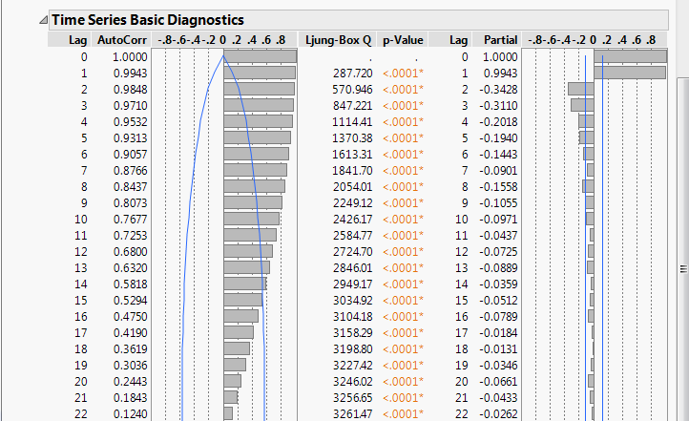
The autocorrelation and partial autocorrelation plots are displayed. These plots are useful to identify candidate models that account for the autocorrelation that is often present in time series data. However, because of the high correlation with temperature, it is premature at this time to construct models.
To fit a linear regression model with temperature as the independent variable, from the red triangle beside Transfer Function Analysis drop down menu select Transfer Function. The following window appears.
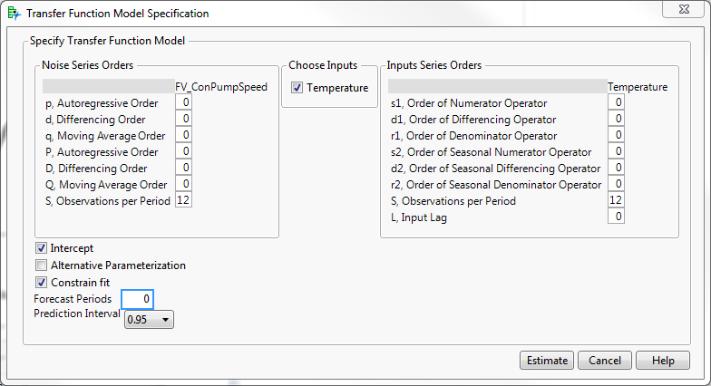
Select Estimate.
The model summary is shown below.
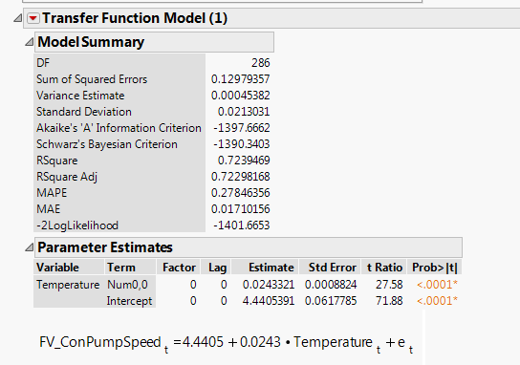
The slope for Temperature is 0.0243 gallons per minute. For every increase of one degree, the average fill volume increases by 0.0243 ounces.
Examine the Residuals.
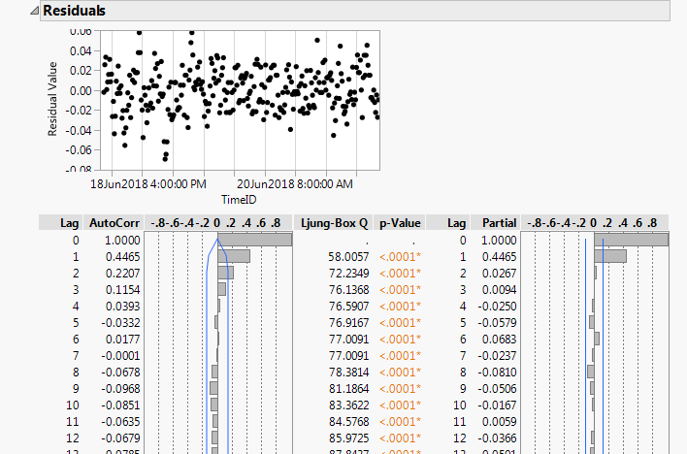
There is no obvious pattern in the residual plot. However, the autocorrelation and partial autocorrelation plots suggest that an autoregressive term of order 1 (AR(1)) is necessary to model the autocorrelation in the residuals.
From the red triangle drop down menu beside Transfer Function Analysis, select Transfer Function again. Enter a one (1) for the Autoregressive Order as show below.
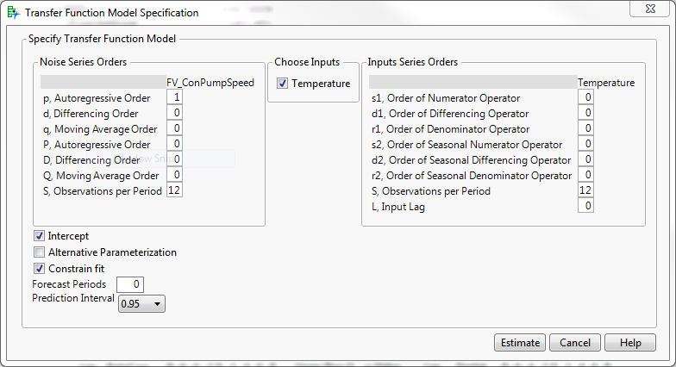
Select Estimate.
The second model summary is shown below.
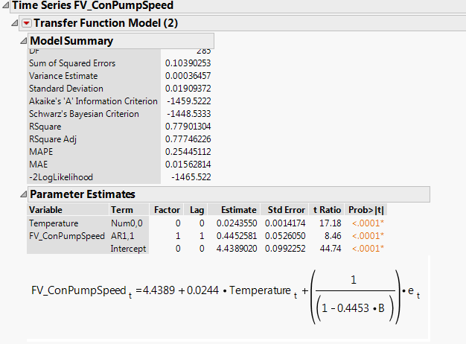
The factor in the last term reflects the AR(1) term in the model. The current value of fill volume depends on temperature but also the fill volume in the previous time interval.
Examine the Residuals.
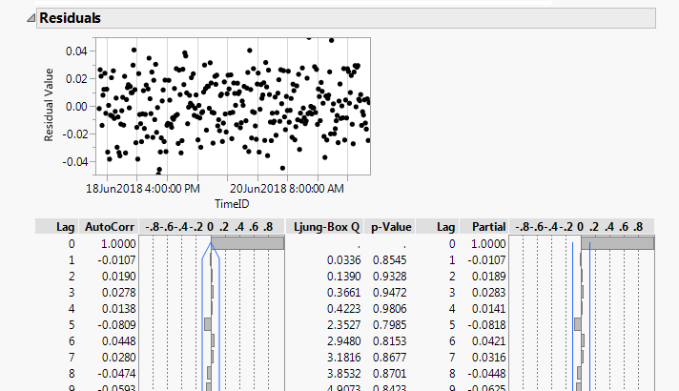
These plots suggest that the AR(1) term is adequate for modeling the autocorrelation in the data.
Now examine the Model Comparison Table.
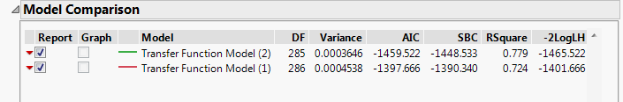
By all the metrics, the second model is superior.
To ascertain how changing pump speed effects fill volume, bring up a new instance of the Time Series Platform and enter assign the variables to their roles as show below.
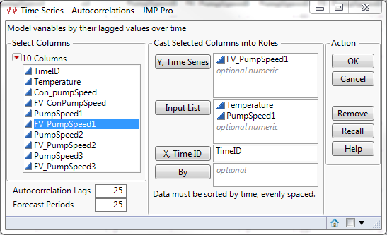

Select OK. The following plots appear.
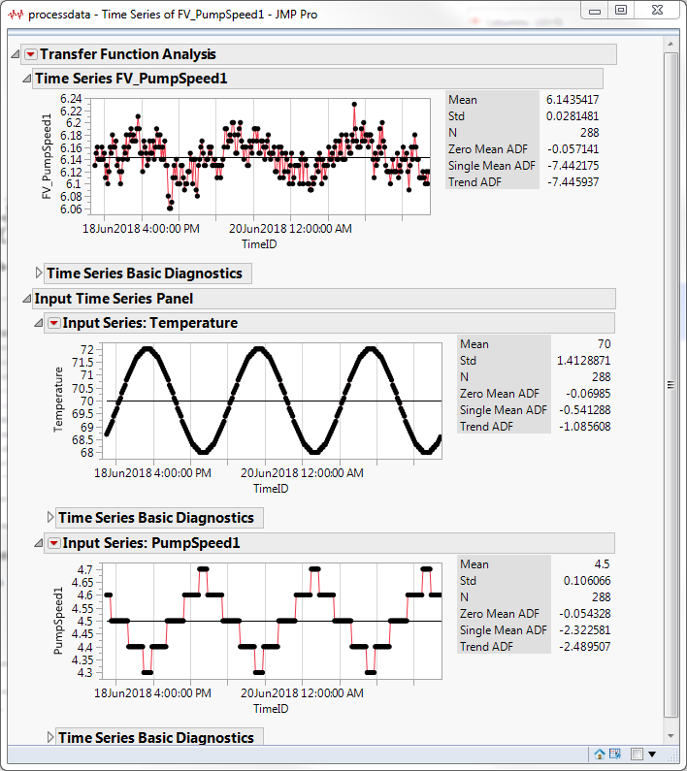
From the Red Triangle beside Transfer Function Analysis drop down menu, select Transfer Function. In the Time Series Model Specification window includes an AR(1) term as shown below.
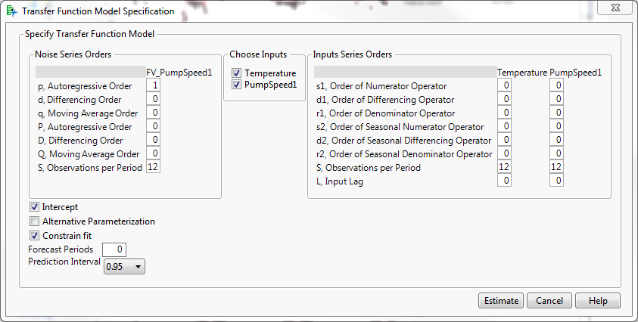
Select Estimate. The model summary appears.
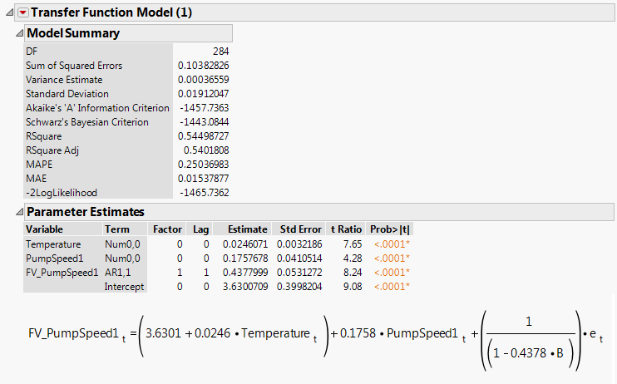
The model indicates that for every one unit increase in temperature fill volume increases by 0.0246 fluid ounces and for every one unit increase in pump speed, fill volume increases by 0.1758 ounces.
Examine the Residuals.
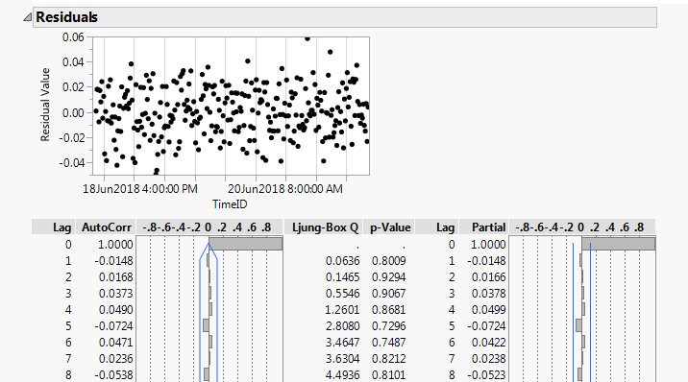
The residuals indicate that the AR(1) term is adequate for modeling the autocorrelation.
Now that the relationship among fill volume, temperature, and pump speed has been quantified, by adjusting pump speed appropriately, the variability of fill volume can be reduced.
Open a new instance of the Time Series Platform. Assign the variables to their roles as shown below.
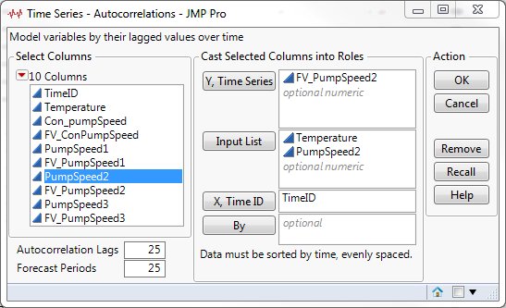
Select OK. The following graphs appear.
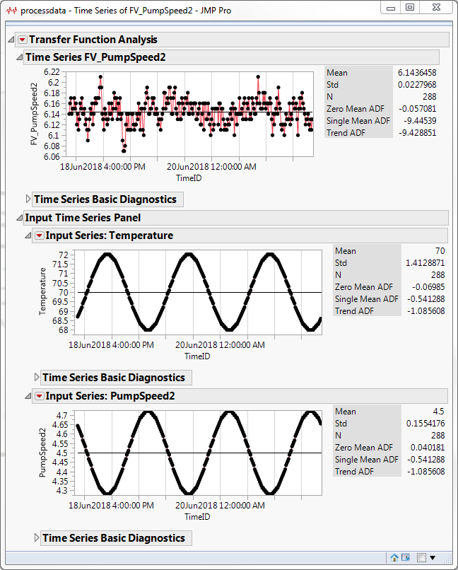
The mean of fill volume has not changed but the standard deviation has dropped from 0.404 to 0.0228, a decrease of about 45 percent. Consequently, the target fill volume can be reduced by reducing the average pump speed to 4.1 gallons per minute.
Open another instance of the Time Series Platform and assign variables and roles as shown below.
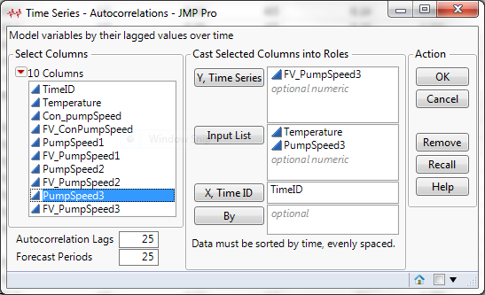
Select OK.
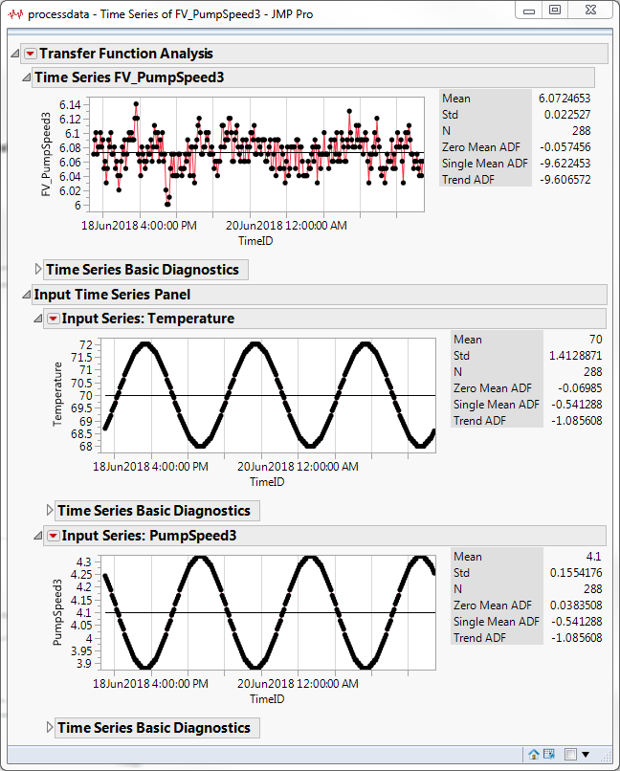
The decrease in average pump speed to 4.1 gallons per minute reduces the average fill volume from 6.144 to 6.072 fluid ounces, a savings of only 0.072 fluid ounces per bottle. However, when the company produces 5 million bottles a year, the total savings is 360,000 fluid ounces and $69,000.
Market Mix Model
Business Application Description
A market mix model is a multiple regression model with the response sales in dollars and inputs the amount of dollars spent on advertising by different media. Because the data is a time series, usually autocorrelation is present so the assumption of independent errors is violated. It is often also the case that there is a delay in advertising spend and impact on sales. Thus spend in some media is a leading indicator of sales in the future.
A market mix model can be used to quantify the return on investment for each dollar spent by the different media. Once the return on investment is quantified, it can be used to allocate future advertising dollars. The model can also be used to plan future advertising strategies by examining different allocation of a total advertising budget.
Market Mix Model Demonstration.
The market mix data table is shown below. It contains the weekly sales and advertising spend for a nonperishable product. The data is based on real data but has been modified for demonstration purposes
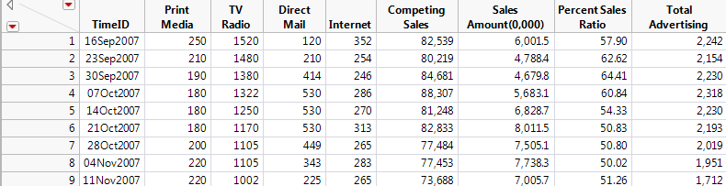
The interval for the TimeID is week. The responses is Sales Amount(0,000) in units of $10,000. There are five candidate inputs. The columns Print Media, TV Radio, Direct Mail, and Internet are dollar spend in units of $1,000. The fifth is Percent Sales Ratio that is a function of Competing Sales and Sales Amount. It is used in the model to account for how competition affects sales. Total Advertising is the sum of spend over all media so is not a viable input if the four media are included.
It is very important when interpreting the model coefficients that one keeps in mind the scale of the response and the inputs
Select Analyze, then Specialized Modeling and then Time Series to open the Time Series Platform Dialog. Assign the variables to their roles as shown below.
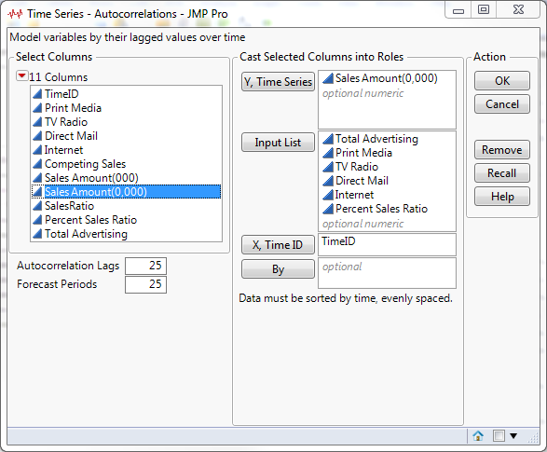
Select OK.
Plots of the response and candidate inputs by week are shown below.
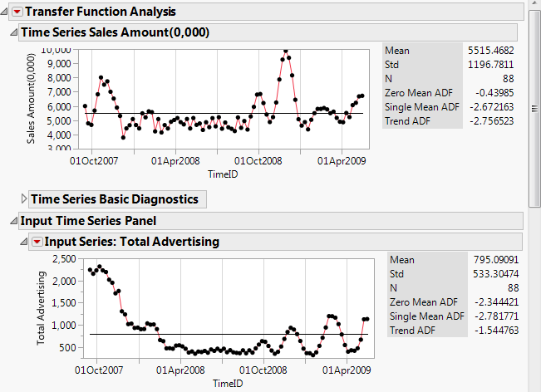
Notice that Sales Amount is rather flat except for a few spikes in late 2007 and late in 2008. Total advertising spend has declined dramatically since late 2007. There appears to be several campaigns in late 2008 and early 2009. Examine the advertising spend by different media in the plots below.
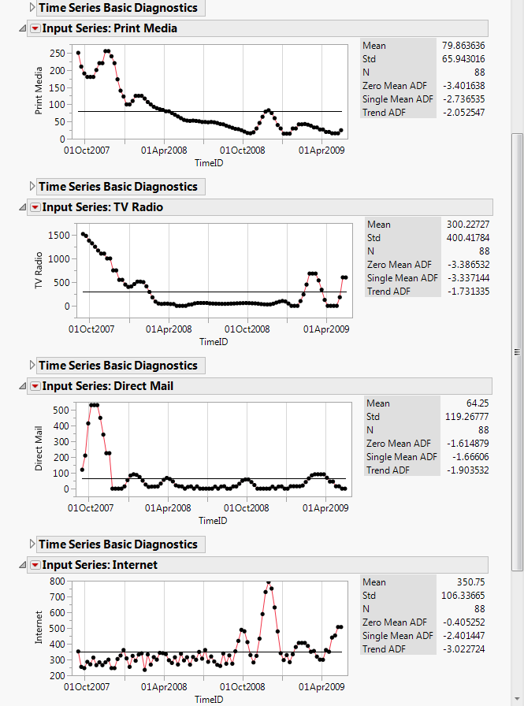
It appears that the internet became a more important part of their advertising strategy starting in late 2008.
To fit the first model, from the red triangle beside Transfer Function Analysis drop down menu, select Transfer Function to bring up the Specify Transfer Function Model window. Configure the options as shown below.
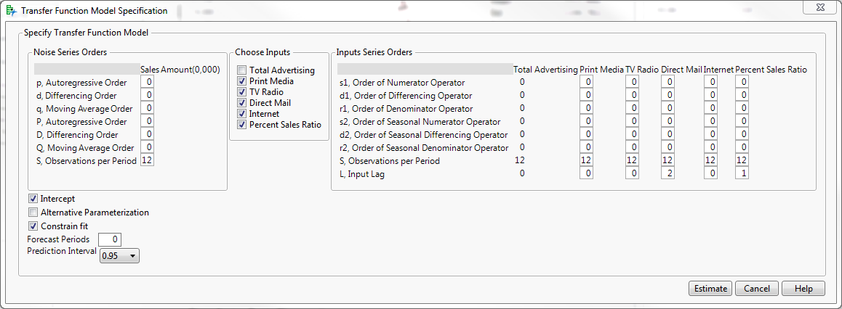
Be sure to uncheck Total Advertising. A lag of two (2) was chosen for Direct Mail based on business knowledge. A lag of one (1) was chosen based on business knowledge and some trial and error.
There are analytical methods to help chose a transfer function form and the lag for inputs that involve a process called Prewhitening. (Box and Jenkins, Chapter 11.). Usually, some trial and error is still needed to arrive at a “best” model.
Select Estimate.
The Parameter Estimates Table is below.
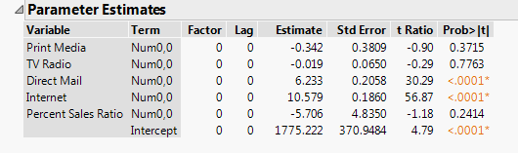
Some of the parameter estimates are not significant. However, because the possible autocorrelation has not been accounted for, it is premature to conclude they are not important. Now examine the model equation.
The subscript for Direct Mail of (t-2) reflects the lag of two (2) specified. The subscript of (t-1) for Percent Sales Ratio reflects the lag or one (1) specified.
Examine the Residuals.
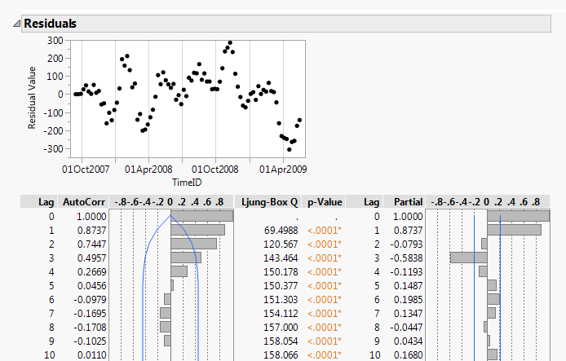
The pattern of the residual plot and in the autocorrelation and partial autocorrelation plots indicate that there is strong autocorrelation in the residuals. The large spike at lag three (3) in the partial autocorrelation plot suggest that an autoregressive term of order three (3) (AR(3)) is needed.
Bring up a second instance of the Transfer Function Model Specification window and specify the options as shown below.
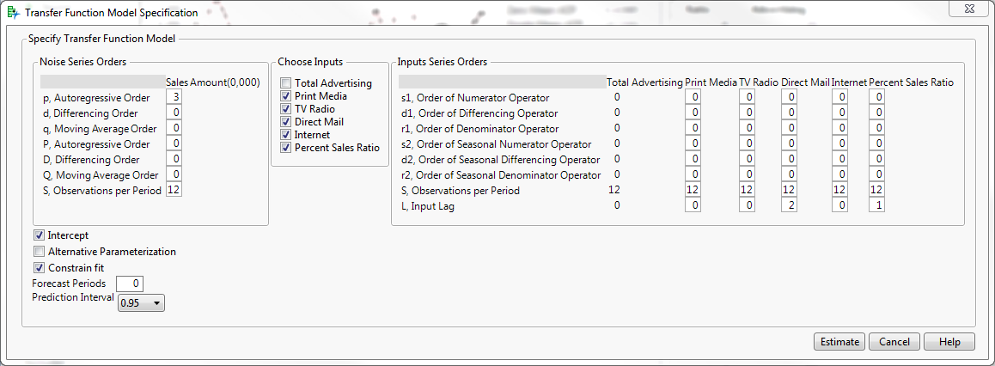
The only change from the previous model is the inclusion of the AR(3) specification.
Select Estimate.
The parameter estimates for the second model are shown below.
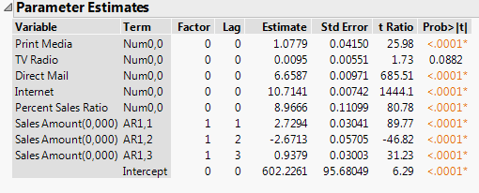
Print Media and Percent Sales Ratio parameters are now significant. TV Radio parameter is still not significant but its p-value is much smaller than before.
Expand the Residuals window to ascertain if autocorrelation remains in the residuals.
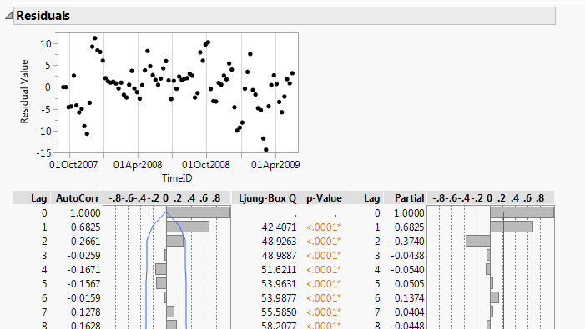
The plots indicate that there is still autocorrelation in the residuals. The plots suggest that higher order autoregressive terms maybe needed.
After trying AR(4) and AR(5) terms, the algorithm that estimates the parameters failed to converge. Convergence problems can happen when trying to fit time series models with a large number of parameters. A given data set only will support models up to a specific level of complexity.
Though this model may not be perfect, it is useful. The model equation is shown below.
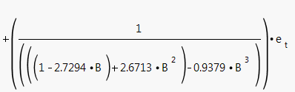
The regression coefficients in the model and be interpreted in the following way.
The Print Media coefficient is 1.078. Keeping in mind the difference in scale, for every dollar spent on Print Media advertising returns $10.78. For Direct Mail, for every dollar spent two weeks before increase sales by $66.59 in the current week. The other advertising coefficients can be interpreted similarly.
Interpreting the actual values of the autoregressive terms is difficult. The most important fact is that sales in the current week not only depend on the recent advertising spend and also on actual sales in the prior three weeks.
The Interactive Forecasting feature can be used to illustrate the usefulness of the model.
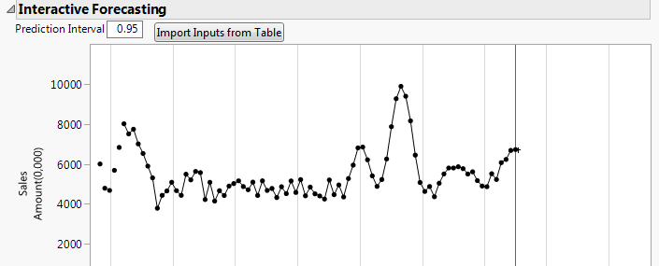

Select Import Inputs from Table.
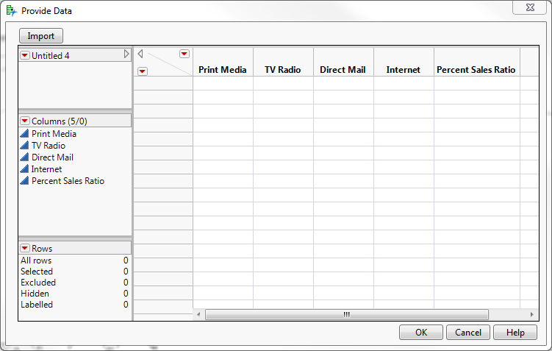
A data table appears with columns named for the inputs in the model.
Future sales as a function of the inputs can be produced by allocating the advertising budget to the different media. For example, reallocate $100,000 from TV radio to Direct Mail as shown below. Recall that the units of advertising spend are in thousands.
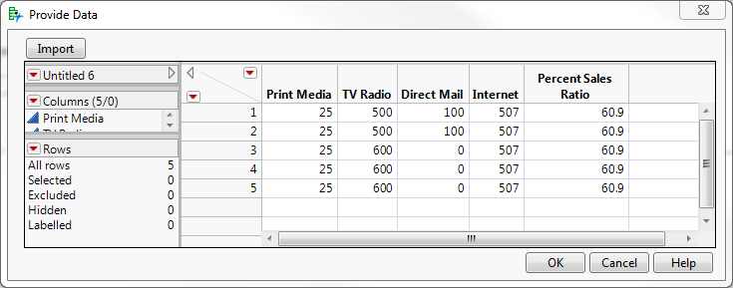
The forecast based on these values is shown below.
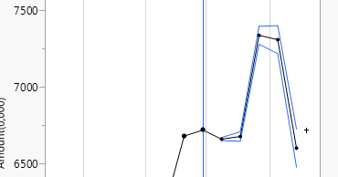

The three-step ahead forecast reflects the two-week lag in the effect of the increase in Direct Mail spend. The blue lines are the 95% confidence bounds
Conclusions.
The JMP® Time Series Platform was used to fit dynamic regression models that are useful in industry and business. A dynamic regression model was used to reduce the variability of a manufacturing process that resulted in substantial cost savings. A dynamic regression models was used to develop a business market mix model that allows one to examine the impact on sales of different allocations of marketing dollars to different media.
Acknowledgements.
I thank my wife, Rosemary Batten Lucas for he helpful comments in reviewing my manuscript. I also thank SAS Education for allowing me to use the market mix data. I also thank my anonymous friend for taking the time to describe the manufacturing process and review my simulation for realism. I also thank the Discovery Conference Steering Committee for accepting my talk.

References
Box, G. E. P. and Jenkins, G. M. 1976. Time Series Analysis forecasting and control. Holden-Day San Francisco.
SAS Institute Inc. 2018. JMP® 14 Predictive and Specialized Modeling. Cary, NC: SAS Institute Inc.

Contact Information:
Email: robertlucas1972@gmail.com

